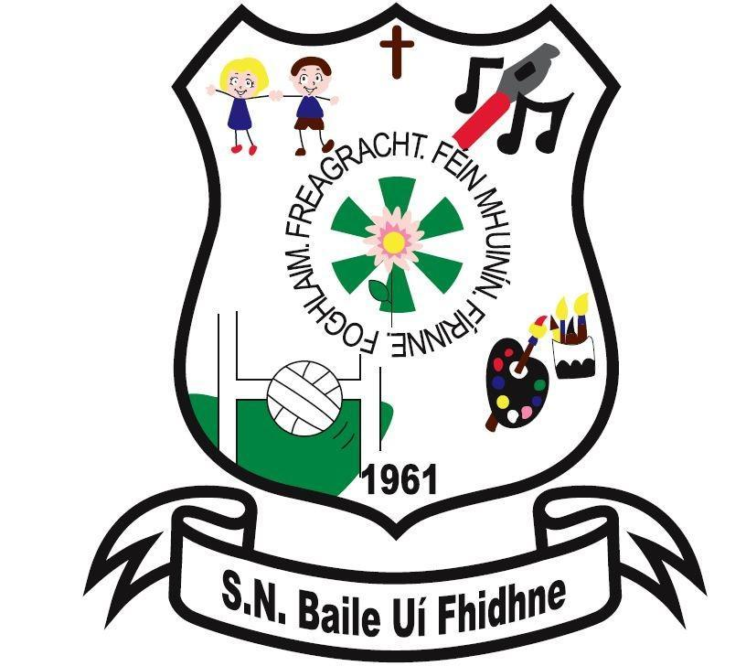

Ballyfeeney NS Code of Behaviour

Scramogue

Co Roscommon

F42 WV63

Tel:0719633855

Email:[ballyfeeneyns@gmail.com](mailto:ballyfeeneyns@gmail.com)

**Code of Behaviour**

**Scoil Náisiúnta Baile Uí Fhidhne**

The Department of Education has requested all Boards of management to draw up Codes of Behaviour for their schools in consultation with parents and teachers.

What follows is the agreed code for our school. The code includes the provisions suggested by the Department in its guidelines to Boards of Management.

**Aims and Objectives**

1. That all children should be enabled to develop socially and academically in a happy, safe and congenial environment.
2. That all children should be trained in good manners, punctuality and respect for others and for their environment.

**General Behaviour**

1. Pupils should show respect for themselves, for each other and for the staff, for school property and its environment.
2. Bullying of any kind shall not be tolerated. Hurtful comments and personal remarks aimed at other children are most objectionable.
3. Offensive language of any sort will not be allowed.
4. Good Behaviour is expected while engaged in school activities.
5. No pupil may enter another classroom without prior permission from either teacher.
6. Please adhere to the healthy lunch policy.

g) Tippex or similar toxic material is not allowed by any pupil in school. Aerosol deodorants are not allowed in school (a roll-on stick variety is acceptable). See Substance Use & Abuse Policy

h) Running, shouting, pushing or any similar activity in the school building is forbidden.

i) Loitering in the school toilets is forbidden.

j) Children are not permitted to have mobile phones in class or in the school yard. If a child is found to have a mobile phone, it will be confiscated. In exceptional circumstances arrangements may be made between the principal and parents of the school child to hold a phone for the child in the office, for use after school hours.

k) Encouraging a child to hit back is mistaken because it does not address the reasons for aggressive behaviour and it could result in a child being seriously hurt. (See Anti-Bullying Policy).

l) Coughing on, sneezing purposely at another child is strictly forbidden.

**Attendance and Punctuality**

1. School hours are from 9.20a.m. to 3.00p.m., with a 10 minute break at 11.00a.m. and half hours break from 12.30p.m. - 1.00p.m, or as may be changed from time to time, which will be notified to pupils and their parents/guardians. Children should not be in the school grounds outside of school hours in the interests of personal safety.
2. Pupils must attend regularly and punctually.
3. Pupils are not allowed to leave the school grounds between 9.20a.m. and 3.00p.m. without the written permission or personal attendance of parents/guardians.
4. Infants must be collected at 2.00p.m. each school day.
5. When a pupil is absent from or late for school a note of explanation **must** be sent to the class teacher.
6. Each family will be notified of holidays and school closings.

**Work**

1. Each pupil is expected to work diligently in school and to co-operate with his/her teacher at all times.
2. Homework reinforces work done in school and is therefore an essential component of the learning process. Homework - written and oral - should be carried out conscientiously.
3. Pupils should be equipped with all school books prescribed by their class teacher. All books should be kept in good condition, covered and present in school with the child on the first day of the new school term.

**Dress and Appearance**

1. Pupils should wear the school uniform in school. In the interest of safety, children are expected to have suitable footwear for P.E.
2. Pupils are expected to be clean, neat and tidy in dress and appearance.
3. For safety reasons, jewellery is not allowed except for one small stud earring in the bottom of each ear and a watch.
4. Hairstyles are expected to be neat and conventional- with hair in its natural colour. For hygiene purposes hair should be tied back.

## **Class Rules**

At the beginning of each academic year, the class teacher will draft a list of class rules with the children. Class rules will be kept to a minimum and are devised with regard for the health, safety and welfare of all members of the school community. Where possible they emphasise positive behaviour (e.g. ‘Walk’ and not, ‘Don’t run’). Rules will be applied in a fair and consistent manner, with due regard to the age of the pupils and to individual difference. Where difficulties arise, parents will be contacted at an early stage.

## **Incentives/Reward System**

Part of the vision of our school is to help children achieve their personal best and thus prepare them for further education, life and work. We recognise that there are many different forms of intelligence and similarly that children use a variety of approaches to solve problems. Our reward system seeks to provide encouragement to all children of all abilities and talents. Children will be encouraged, praised and listened to by adults in the school. Praise is earned by the maintenance of good standards as well as by particularly noteworthy personal achievements. Rates of praise for behaviour should be as high as for work.

The following are some samples of how praise might be given:

* A quiet word or gesture to show approval
* A comment in a pupil’s copy or homework journal
* A visit to another member of Staff or to the Principal for commendation
* A word of praise in front of a group or class
* Delegating some special responsibility or privilege
* A mention to parent, written or verbal communication
* Stickers
* Sweets and treats or healthy option i.e. raisins fruit etc. (Should you wish that your child does not receive sweets or chocolate as a reward, and your preference is for a healthy option alternative, please advise the school in writing)
* Homework passes
* Golden time...... (free time when pupil can choose their activity)
* Computer time
* Student of the week
* Gaeilgeóir na seachtaine (best Irish speaker of the week)
* Prizes i.e pencils etc.
* Library time
* Movie

**Procedures in Relation to Breaches of Discipline**

In the implementation of any sanctions, it should be noted that it is the behaviour that is rejected and not the child. The overall responsibility for discipline within the school rests with the Principal. Each teacher has responsibility for the maintenance of discipline within his/her own classroom while sharing a common responsibility for good order within the school premises.

A child will be referred to the Principal for serious breaches of discipline and for repeated incidents of minor misbehaviour.

The following strategies may be used to show disapproval of unacceptable behaviour. The nature of the behaviour and the age of the child will determine the nature of the strategy employed.

**Discipline Hierarchy**

a) Reasoning with child. (Traffic Lights)

b) Reprimand (including advice on how to improve).

c) Temporary separation from class. (Time-out) and /or

-Loss of privileges (not deprived of a curricular area except on the grounds of Health/Safety where they pose a serious threat to themselves or others)

-Detention during break or lunch time.

-Prescribing additional work.

-Child may have to write a story explaining about bad behaviour, story to be signed by parent/guardian.

d) Communication with parents/guardians (Individual Behaviour Plan)

e) Referral to another teacher/Principal.

f) Older children may not be allowed to go on the school tour if no effort is made to improve after repeated corrections.

g) Internal suspension: if the staff feel it is appropriate a pupil is removed from their own base class and is placed in another school class for up to three days. This will be activated when stages a-e are exhausted

h) Suspension (temporary).

i) Expulsion (in accordance with the Education Act 1998 and the Welfare Act 2000)

In dealing with all misbehaviour allegations and investigations the staff will follow fair procedures, (make sure the child knows what he/she is being accused of; hearing both sides of the story; avoiding perceived bias; come to as fair and reasonable a conclusion as possible).

The school will adhere to fair procedures, and in particular where sanctions may include a suspension and/or expulsion. However, the Board of Management is committed to ensuring the health and safety of the pupils and teachers of the school, and also ensuring that the teaching and learning process in the school is not significantly disrupted. These factors will be considered when dealing with breaches of discipline.

Parents are requested to familiarize themselves with this policy and to co-operate with the school with regard to its implementation. Parents should communicate regularly with the school about factors likely to affect the behaviour of their children.

Every effort will be made by teachers to adopt a positive approach to the question of behaviour in the school. Children will be rewarded now and again for good behaviour, and school work or homework that has been well done, various types of rewards will be used (including but not limited to those rewards outlined above).

Parents are expected to:

· Ensure their children attend school and are punctual

· Equip pupils with appropriate school materials, a sufficient healthy lunch and full uniform

· Be courteous towards pupils and staff

· Make an appointment to meet with a teacher/the Principal through the office

· Respect school property and encourage their children to do the same

· Label pupils coats and other personal property

· Strictly supervise pre-school children, when in the school.

As the Board of Management is responsible for the Health & Safety of all staff and students, parents are requested not to approach or reprimand another person’s child on the school premises.

**Social Media – References to our school, staff and students**

As a school, we encourage you to support our school community (staff, parents and students) with the education and wellbeing of your child. If, at any time, there are issues regarding your child you should speak with the relevant teacher. Should you wish to make a complaint then you are advised to follow the school’s Parental Complaints Procedure.

You are expected to refrain from discussing school business, children attending this school or members of staff in an inappropriate or offensive manner in any public forum including social media sites. As a school, we cannot condone the use of social media to criticise and make comments about the school, its pupils or any members of staff, or any member of the school community.

Our school values its good name and as a school community we will protect and uphold that good name. Instances where defamatory comments are made which tarnish, or bring into disrepute this school or any member of the school community (whether named or implied) will be taken very seriously. The right to ones good name is protected under the Constitution of Ireland (Article 40.3.2) and the Defamation Act 2009.

Ratified: ____________________ B.O.M

Date: _________________

The enclosed code of behaviour has been accepted and approved by the Board of Management. Please acknowledge receipt of the same.