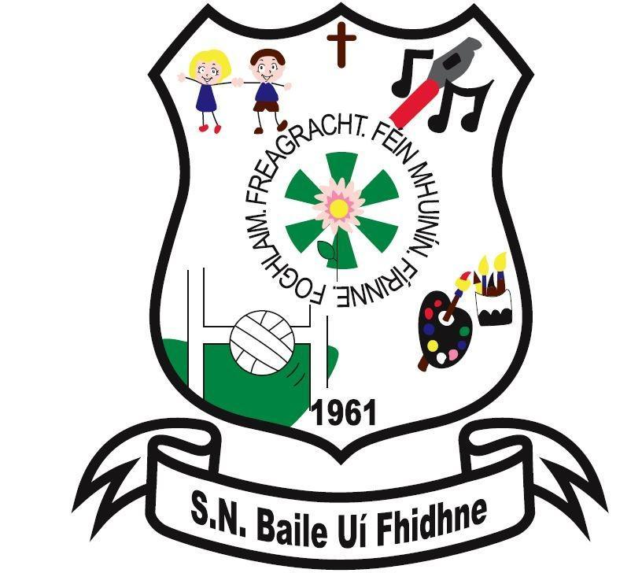

Mission Statement

Ballyfeeney NS

Scramogue

Co Roscommon

F42 WV63

Tel:0719633855

Email:[ballyfeeneyns@gmail.com](mailto:ballyfeeneyns@gmail.com)

**Ballyfeeney National School**

# Mis**sion Statement**

Ballyfeeney N.S. is a rural Primary School with a catholic ethos. At Ballyfeeney National School we strive to learn together in a happy and safe environment, where everyone is valued, respected and encouraged to do their best.

In order to achieve our vision we have drawn up the following aims:

* To enable the child to live a full life as a child and to equip him/her to avail of further education
* To create a happy atmosphere where the child can enjoy school while developing spiritually, morally, socially, intellectually, emotionally and physically
* To value each child as an individual and to develop a sense of his/her own worth through developing self confidence, self expression and the ability to relate to peers and adults
* To help the child to have respect for self, peers, neighbours and the environment
* To develop knowledge, skills and attitudes, a spirit of inquiry, and the capacity to analyse issues critically and constructively.
* To develop expressive, creative and artistic abilities to the individual’s full capacity
* To foster a spirit of self-reliance, innovation and imagination
* To promote physical and emotional health and well-being
* To create tolerant, caring, politically aware members of society
* To foster in pupils a global awareness and a sense of responsibility for the long-term care of the environment
* To respect the rights of the parents as the primary educators of their children, and to establish a good working relationship with them
* Deánfaimid iarracht Gaeilge a labhairt.