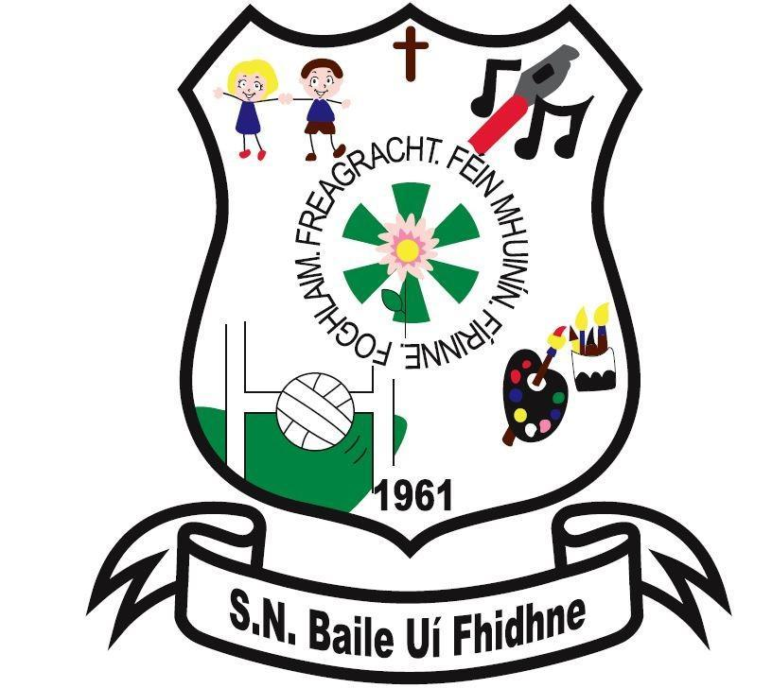

Ballyfeeney NS Ethos

Scramogue

Co Roscommon

F42 WV63

Tel:0719633855

Email:[ballyfeeneyns@gmail.com](mailto:ballyfeeneyns@gmail.com)

**Ballyfeeney National School**

**Ethos**

The ‘ethos’ of Ballyfeeney National School encompasses collective attitudes, beliefs, core values, traditions, aspirations and goals. These are reflected in the actual practices which are carried out in the school on a daily, weekly and yearly basis. While it is impossible to outline all aspects of the school ‘ethos’, the following characteristics are experienced and promoted as essential elements in the establishment of a supportive and positive ‘ethos’.

* In Ballyfeeney National School, where the ethos is that of a Christian Catholic school, religious instruction, in accordance with the doctrine and tradition of the Catholic Church is part of the education given to children who belong to that Church.
* The pupils are prepared for the reception of the sacraments of First Confession, First Holy Communion and Confirmation, in accordance with arrangements in the diocese.
* Prayer is a feature of the school day.
* We provide sacred spaces to encourage communal prayer and thanksgiving ceremonies.
* The school aims at promoting the full and harmonious development of all aspects of the pupil, including his / her relationship with God, with other people and with the environment. Opportunities are provided for pupils to use their gifts for the common good and to work for a more caring society e.g participating in Christmas Shoebox Appeal, contributing money to good causes.
* The Principal and teaching staff aim at maintaining high professional standards and creating a safe and happy environment.
* A spirit of mutual respect is promoted within the school community. Pupils are drawn by example and teaching to appreciate and respect people of different religious affiliations and of different nationalities.
* Close contact is maintained between school and home. Parents / guardians and teachers support one another and collaborate with one another in leading the children to the fullness of their potential at the different stages.
* Ancillary staff in the school are highly esteemed and respected. It is recognised that their work makes a valued contribution to the process of education.