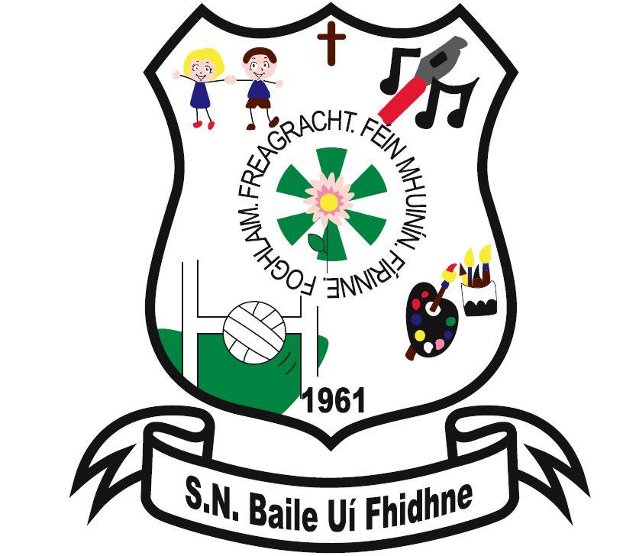

**Curriculum**

Ballyfeeney NS is dependent on the Department of Education and Skills for grants and teacher resources and our school operates within regulations laid down by the DES.

The Primary School Curriculum, Department of Education and Skills (1999), informs all aspects of teaching and learning in our school.

The Curriculum is presented in seven areas.

*Language: Gaeilge and English*

*Mathematics*

*Social, environmental and scientific education (SESE): History, Geography and Science*

*Arts Education: Visual Arts, Music and Drama*

*Physical Education*

*Social, Personal and Health Education (SPHE)*

As a school with a Catholic ethos the Grow in Love Religious Education Programme is taught. Roman Catholic pupils are prepared for the sacraments of First Confession, First Holy Communion and Confirmation.

First Holy Communion is celebrated in Kilglass Church and Confirmation is celebrated with pupils from neighbouring schools in one of our local parish churches.