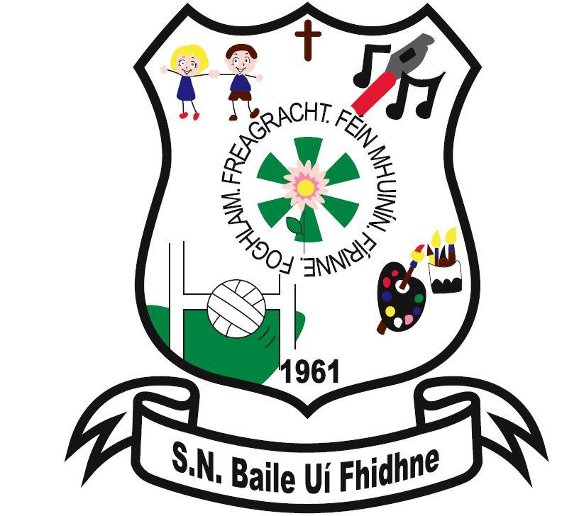

**Information Booklet for Parents/Guardians of pupils starting their Primary Education at Ballyfeeney NS**

**School Principal: Caitriona McDonnell**

**Chairperson: Joe Murphy**

**Deputy Principal: Fidelma Owens**

**School Telephone: 071-9633855**

**Email:ballyfeeneyns@gmail.com**

**When you thought I Wasn’t Looking**

Mary Rita Schilke Korzan

When you thought I wasn’t looking,

I saw you hang my first painting on the refrigerator,

And I wanted to paint another one.

When you thought I wasn’t looking,

I saw you feed a stray cat,

And I thought it was good to be kind to animals.

When you thought I wasn’t looking,

I saw you make my favourite cake for me,

And I knew that little things are special things.

When you thought I wasn’t looking,

I heard you say a prayer,

And I believed there is a God I could always talk to.

When you thought I wasn’t looking,

I felt you kiss me goodnight, and I felt loved.

When you thought I wasn’t looking,

I saw tears come from your eyes,

And I learned that sometimes things hurt, but it is all right to cry.

When you thought I wasn’t looking,

I saw that you cared, and I wanted to be everything that I could be.

When you thought I wasn’t looking,

I looked…………..,

And wanted to say thanks for all the things I saw when you thought I wasn’t looking.

***Vision: At Ballyfeeney National School we strive to learn together in a happy and safe environment, where everyone is valued, respected and encouraged to do their best***

**Board of Management of Ballyfeeney NS**

Chairperson: Joe Murphy

Principal: Caitriona McDonnell

Patron’s Nominee: Fr Evaristus

Teacher’s Representative: Rachel Lavin

Community Representative: Sinead Connellan

Community Representative: Gary Fisher

Parent’s Representative: Helen English

Parent’s Representative: Ronnie Duignan

**Our School Day**

9:20am: School Opens

11:00am-11:10am: Small Break

12:30-1:00pm: Lunch Break

2:00pm: Home Time – Junior & Senior Infants

3:00pm: Home Time 1st – 6th class

**The Board of Management is not responsible for children before 9:20 a.m. or after 3:00 p.m. The Board of Management cannot accept responsibility for the children who arrive on the school premises before the normal time of opening and/or who remain on the school grounds after school times. The B.O.M. is unable to guarantee supervision at these times.**

**Child Safeguarding Statement**

Ballyfeeney National School is a primary school providing primary education to pupils from Junior Infants to Sixth Class.

In accordance with the requirements of the Children First Act 2015, Children First: National Guidance for the Protection and Welfare of Children 2017, the Child Protection Procedures for Primary and Post Primary Schools 2017 and Tusla Guidance on the preparation of Child Safeguarding Statements, the Board of Management of Ballyfeeney National School has agreed the Child Safeguarding Statement set out in this document.

1. The Board of Management has adopted and will implement fully and without modification the Department’s Child Protection Procedures for primary and post-primary Schools 2017 as part of this overall Child Safeguarding Statement.
2. The Designated Liaison Person (DLP) is Mrs Fidelma Owens
3. The Deputy Designated Liaison Person (Deputy DLP) is Mrs Caitriona McDonnell
4. The Board of Management recognises that child protection and welfare considerations permeate all aspects of school life and must be reflected in all of the school’s policies, procedures, practices and activities. The school will adhere to the following principles of best practice in child protection and welfare. The school will:
   1. recognise that the protection and welfare of children is of paramount importance, regardless of all other considerations
   2. fully comply with its statutory obligations under the Children First Act 2015 and other relevant legislation relating to the protection and welfare of children
   3. fully co-operate with the relevant statutory authorities in relation to child protection and welfare matters
   4. adopt safe practices to minimise the possibility of harm or accidents happening to children and protect workers from the necessity to take unnecessary risks that may leave themselves open to accusations of abuse or neglect
   5. develop a practice of openness with parents and encourage parental involvement in the education of their children; and
   6. fully respect confidentiality requirements in dealing with child protection matters

The school will also adhere to the above principles in relation to any adult pupil with a special vulnerability.

1. The following procedures/measures are in place:
   1. In relation to any member of staff who is the subject of any investigation (howsoever described) in respect of any act, omission or circumstance in respect of a child attending the school, the school adheres to the relevant procedures set out in Chapter 7 of the Child Protection Procedures for Primary and Post-Primary Schools 2017 and to the relevant agreed disciplinary procedures for school staff which are published on the DES website
   2. In relation to the selection or recruitment of staff and their suitability to work with children, the school adheres to the statutory vetting requirements of the National Vetting Bureau (Children and Vulnerable Persons) Acts 2012 to 2016 and to the wider duty of care guidance set out in relevant Garda vetting and recruitment circulars published by the DES and available on the DES website
   3. In relation to the provision of information and, where necessary instruction and training to staff in respect of the identification of the occurrence of harm (as defined in the 2015 Act) the school:
      1. Has provided each member of staff with a copy of the school’s Child Safeguarding Statement
      2. Ensures all new staff are provided with a copy of the school’s Child Safeguarding Statement
      3. Encourages staff to avail of relevant training
      4. Encourages Board of Management members to avail of relevant training
      5. The Board of Management maintains records of all staff and Board member training.
   4. In relation to reporting of child protection concerns to Tusla, all school personnel are required to adhere to the procedures set out in the Child Protection Procedures for Primary and Post-Primary Schools 2017, including in the case of registered teachers, those in relation to mandated reporting under the Children First Act 2015
   5. In this school, the Board has appointed the above named DLP as the ‘relevant person’ (as defined in the Children First Act 2015) to be the first point of contact in respect of the school’s child safeguarding statement.
2. All registered teachers employed by the school are mandated persons under the Children First Act 2015
3. In accordance with the Children First Act 2015, the Board has carried out an assessment of any potential for harm to a child while attending the school or participating in school activities. A written assessment setting out the areas of risk identified and the school’s procedures for managing those risks is attached as an appendix to these procedures
4. The various procedures referred to in this Statement can be accessed via the DES website or will be made available on request by the school

1. This statement has been provided to all members of school personnel, the Parents’ Association and the patron. It is readily accessible to parents and guardians on request. A copy of this Statement will be made available to Tusla and the Department if requested.
2. This Child Safeguarding Statement will be reviewed annually or as soon as practicable after there has been a material change in any matter to which this statement refers

This Child Safeguarding Statement was adopted by the Board of Management on February 7th, 2018 and reviewed on January 18th, 2021.

**CODE OF BEHAVIOUR**

**Scoil Náisiúnta Baile Uí Fhidhne**

The Department of Education has requested all Boards of management to draw up Codes of Behaviour for their schools in consultation with parents and teachers.

Every member of the school community has a role to play in the implementation of the Code of Behaviour. The school hopes that by keeping rules to a minimum and by explaining them clearly to the children both at the beginning and throughout the school year that the pupils are more likely to accept and obey them. By doing this we hope that children will see the necessity for rules to provide a safe, happy and disciplined atmosphere in the school and its environment.

Rules will be applied in a fair and consistent manner, with due regard to the age of the pupils and to individual difference. Good behaviour will be encouraged and rewarded. Where difficulties arise, parents will be contacted at an early stage.

What follows is the agreed code for our school. The code includes the provisions suggested by the Department in its guidelines to Boards of Management.

**Principles**

* Ballyfeeney N.S. recognises the variety of differences that exist between children and the need to tolerate these differences while acknowledging the right of each child to education in a relatively disruptive free environment.
* It is agreed that a high standard of behaviour requires a strong sense of community within the school and a high level of co-operation among staff and between staff, parents and pupils.
* Every effort will be made to ensure that the Code of Behaviour is implemented in a reasonable, fair and consistent manner.

**Aims**

**Guidance**

To provide guidance for pupils, teachers and parents on behavioural expectations.

**Respect**

To encourage respect, trust, consideration and support for others.

**Self-esteem**

To develop in every pupil a positive sense of worth.

**Co-operative learning**

To create mutual respect between pupils and teachers and between pupils themselves.

**Learning environment**

To provide a happy, stable and secure learning environment.

**GENERAL BEHAVIOUR**

* Pupils are expected to treat all adults and fellow pupils with respect and courtesy at all times. Behaviour that interferes with the rights of others to learn and to feel safe is unacceptable.
* Bullying is **repeated** verbal, psychological or physical aggression by an individual or group against others. The most common forms of bullying are aggressive physical contact, name-calling, intimidation, extortion, isolation and taunting. Hurtful comments and personal remarks aimed at other children/staff are most objectionable.

Bullying will not be tolerated and parents/guardians will be expected to cooperate with the school at all times in dealing with instances of bullying in accordance with the school’s Anti-Bullying Policy which is available in the school. Encouraging a child to hit back is mistaken because it does not address the reasons for aggressive behaviour and it could result in a child being seriously hurt. (See Anti-Bullying Policy).

* Offensive language and swearing will not be tolerated.
* Good behaviour is expected while children are engaged in all school activities.
* Pupils are expected to show respect for all school property. Writing on school furniture and property is strictly forbidden. Damage to school property/other people’s property must be made good.
* Pupils are expected to be responsible in dealing with litter and are expected to keep the school environment clean and litter free. Pupils must co-operate fully in any organised clean-up activity. Plastic gloves are provided when collecting rubbish.
* No pupil may enter another classroom without prior permission from either teacher.
* Please adhere to the healthy lunch policy
* Running, shouting, pushing or any similar activity in school corridors is strictly forbidden.
* Loitering in school toilets is not permitted.
* Pupils go outside for breaks except when all pupils stay inside due to inclement weather. If you wish your child to remain indoors due to sickness, please inform the child’s class teacher in writing.
* Pupils are not permitted to climb walls, gates or barriers in the school grounds.
* Pupils must wear gum shields for all GAA activities.
* Tippex or similar toxic material is not allowed by any pupil in school. Aerosol deodorants are not allowed in school (a roll-on stick variety is acceptable). See Substance Use & Abuse Policy
* Chewing gum and Football/Soccer cards/children’s own toys are not permitted on school grounds.
* The school cannot be responsible for the loss of student property.

Valuables should not be brought to school. Pupil’s own toys - dolls, computer games, football/soccer cards etc. are not allowed on school grounds.

Money should not be brought to school unless it is specifically required for school purposes.

**If it is required please ensure money is in a sealed envelope with pupil’s name and details of payment clearly written on outside of envelope.**

* For safety reasons, jewellery is not allowed except for one small stud earring in the bottom of each ear and a watch.

**Mobile Phones**

**Children are not allowed to carry mobile phones**. If your child must have a mobile phone, please discuss this with your child’s class teacher. If permitted the mobile phone must be left in the care of the class teacher during school hours. **If a child brings a mobile phone to school without permission it will be confiscated.** In this case the pupil’s Parent/Guardian must contact the class teacher to arrange a suitable time for the phone to be returned.

**ATTENDANCE AND PUNCTUALITY**

* School hours are from 9.20a.m. to 3.00p.m., with a 10 minute break at 11.00a.m. and half hours break from 12.30p.m. - 1.00p.m, or as may be changed from time to time, which will be notified to pupils and their parents/guardians. Pupils eat their lunch from 12:30-12:40pm and play outside for the remaining 20 minutes.
* Children should not be in the school grounds outside of school hours in the interests of personal safety. The insurance company has advised us that no responsibility can be accepted for pupils who arrive early or children who are still on the school grounds after 3:00p.m.
* On arrival, please walk your child to the school gate and meet your child at the school gate on departure.
* Pupils must attend regularly and punctually.
* Pupils are not allowed to leave the school grounds between 9.20a.m. and 3.00p.m. without the **written permission or personal attendance** of parents/guardians. Parents must inform the class teacher if the child will be returning.
* Infants must be collected at 2.00p.m. each school day. It is not possible for any infant to remain in school after 2pm so please make suitable arrangements for collection prior to the commencement of the school term.
* ***As a parent/guardian, you must let the school know if your child is absent/late for school and the reason why.***

***It is school policy that reasons must be given in writing.***

*The school must notify Túsla if a child is absent for 20 days or more in the school year, even if those absences are accounted for by letter****.***

* Each family will be notified of holidays and school closings. Please ensure you inform the school immediately if your contact number/email address or home address has changed.

**WORK**

* Each pupil is expected to work diligently in school and to co-operate with his/her teacher at all times obeying a teacher’s instructions, working to the best of their ability and presenting assignments neatly.
* Homework reinforces work done in school and it is therefore an essential component of the learning process. Homework - written and oral - should be carried out conscientiously.
* Pupils should be equipped with all school books prescribed by their class teacher. All books should be kept in good condition, covered and present in school with the child on the first day of the new school term.
* Pupils are expected to participate in all school activities-choir, football, coaching etc.

**DRESS AND APPEARANCE**

* Pupils should wear the school uniform in school. In the interest of safety, children are expected to have suitable footwear for P.E.
* Pupils are expected to be clean, neat and tidy in dress and appearance.
* For safety reasons, jewellery is not allowed except for one small stud earring in the bottom of each ear and a watch.
* Hairstyles are expected to be neat and conventional- with hair in its natural colour. For hygiene purposes hair should be tied back.

**School Rules**

School rules are kept to a minimum and are devised with regard for the health, safety and welfare of all members of the school community. If a school is to function efficiently, it is necessary that rules and regulations are clearly stated and enforced consistently and fairly.

## Class Rules

At the beginning of each academic year, the class teacher will draft a list of class rules with the children. Class rules will be kept to a minimum and are devised with regard for the health, safety and welfare of all members of the school community. Where possible they emphasise positive behaviour (e.g. ‘Walk’ and not, ‘Don’t run’). Rules will be applied in a fair and consistent manner, with due regard to the age of the pupils and to individual difference. Where difficulties arise, parents will be contacted at an early stage.

**Affirming Positive Behaviour**

Positive reinforcement of good behaviour leads to better self-discipline and we place a greater emphasis on rewards and incentives than on sanctions.

Part of the vision of our school is to help children achieve their personal best and thus prepare them for further education, life and work. We recognise that there are many different forms of intelligence and similarly that children use a variety of approaches to solve problems. Our reward system seeks to provide encouragement to all children of all abilities and talents. Children will be encouraged, praised and listened to by adults in the school. Praise is earned by the maintenance of good standards as well as by particularly noteworthy personal achievements. Rates of praise for behaviour should be as high as for work. The following are some samples of how praise might be given:

* A quiet word or gesture to show approval
* A comment in a pupil’s copy or homework journal
* A visit to another member of Staff or to the Principal for commendation
* A word of praise in front of a group or class
* Individual class merit awards, points award
* Delegating some special responsibility or privilege
* A mention to parent, written or verbal communication
* Stickers
* Sweets and treats or healthy option i.e. raisins fruit etc. (Should you wish that your child does not receive sweets or chocolate as a reward, and your preference is for a healthy option alternative, please advise the school in writing)
* Homework passes
* Golden time...... (free time when pupil can choose their activity)
* Computer time
* Student of the week
* Gaeilgeóir na seachtaine (best Irish speaker of the week)
* Prizes (pencils etc).
* Library time
* Movie

**Procedures in relation to Breach of Discipline**

In the implementation of any sanctions, it should be noted that it is the behaviour that is rejected and not the child.

Each teacher has responsibility for the maintenance of discipline within their classroom whilst sharing a common responsibility for good order within the school premises.

A pupil will be referred to the Principal for serious breaches of behaviour and for repeated incidents of minor misbehaviour.

We will reprimand the pupil whilst at the same time reasoning with him/her and advising on how to improve.

The following strategies may be used to show disapproval of unacceptable behaviour. The nature of the behaviour and the age of the child will determine the nature of the strategy employed.

**Discipline Hierarchy**

a) Reasoning with a child. (Traffic Lights)

b) Reprimand (including advice on how to improve).

c) Temporary separation from class. (Time-out) and /or

-Loss of privileges (not deprived of a curricular area except on the grounds of Health/Safety where they pose a serious threat to themselves or others)

-Detention during break or lunch time.

-Prescribing additional work.

-Child may have to write a story explaining about the bad behaviour, story to be signed by parent/guardian.

d) Communication with parents/guardians (Individual Behaviour Plan)

e) Referral to another teacher/Principal.

f) Older children may not be allowed to go on the school tour/match if no effort is made to improve after repeated corrections.

g) Internal suspension: if the staff feel it is appropriate a pupil is removed from their own base class and is placed in another school class for up to three days. This will be activated when stages a-e are exhausted

h) Suspension (temporary).

i) Expulsion (in accordance with the Education Act 1998 and the Welfare Act 2000)

In dealing with all misbehaviour allegations and investigations the staff will follow fair procedures, (make sure the child knows what he/she is being accused of; hearing both sides of the story; avoiding perceived bias; come to as fair and reasonable a conclusion as possible).

The school will adhere to fair procedures, and in particular where sanctions may include a suspension and/or expulsion. However, the Board of Management is committed to ensuring the health and safety of the pupils and teachers of the school, and also ensuring that the teaching and learning process in the school is not significantly disrupted. These factors will be considered when dealing with breaches of discipline.

Parents are requested to familiarize themselves with this policy and to cooperate with the school with regard to its implementation. Parents should communicate regularly with the school about factors likely to affect the behaviour of their children.

Every effort will be made by teachers to adopt a positive approach to the question of behaviour in the school. Children will be rewarded now and again for good behaviour, and school work or homework that has been well done, various types of rewards will be used (including but not limited to those rewards outlined above).

**Social Media – References to our school, staff and students**

As a school, we encourage you to support our school community (staff, parents and students) with the education and wellbeing of your child. If, at any time, there are issues regarding your child you should speak with the relevant teacher. Should you wish to make a complaint then you are advised to follow the school’s Parental Complaints Procedure.

You are expected to refrain from discussing school business, children attending this school or members of staff in an inappropriate or offensive manner in any public forum including social media sites. As a school, we cannot condone the use of social media to criticise and make comments about the school, its pupils or any members of staff, or any member of the school community.

Our school values its good name and as a school community we will protect and uphold that good name. Instances where defamatory comments are made which tarnish, or bring into disrepute this school or any member of the school community (whether named or implied) will be taken very seriously. The right to one's good name is protected under the Constitution of Ireland (Article 40.3.2) and the Defamation Act 2009.

The enclosed code of behaviour has been accepted and approved by the Board of Management. Please acknowledge receipt of same (Please complete section in Enrolment Form)

**Ballyfeeney N.S.**

**Complaints Procedure by Parents against Teachers Policy**

**Introduction**

The following complaints procedure has been drawn up by the Board of Management and is in accordance with the agreement reached in 1993 between the INTO and CPSMA for dealing with complaints by parents against teachers in areas where the Board has jurisdiction as provided for in the above Agreement. The purpose of this policy is to facilitate the resolution of difficulties where they may arise in an agreed and fair manner. In this agreement ‘days’ means school days. Only those complaints about teachers which are **written and signed** by parents/guardians of pupils may be investigated formally by the Board of Management.

**Five stages** are to be followed in progressing a complaint and the specific timescale to be followed at each stage.

**Stage 1**

1. A parent/guardian who wishes to make a complaint should approach the class teacher with a view to resolving the complaint.
2. Where the parent/guardian is unable to resolve the complaint with the class teacher she/he should approach the Principal with a view to resolving it.
3. If the complaint is still unresolved, the parent/guardian should raise the matter with the Chairperson of the Board of Management with a view to resolving it.

**Stage 2**

1. If the complaint is still unresolved and the parent/guardian wishes to pursue the matter she/he should lodge the complaint in writing with the Chairperson of the Board of Management.
2. The Chairperson should bring the precise nature of the written complaint to the notice of the teacher and seek to informally resolve the matter between the parties within 5 days of receipt of the written complaint.

**Stage 3**

If the complaint is not resolved informally, the Chairperson should:

1. Supply the teacher with a copy of the written complaint
2. Arrange a meeting with the teacher and, where applicable, the Principal with a view to resolving the complaint.

Such a meeting should take place within 10 days of receipt of the written complaint.

**Stage 4**

1. If the complaint is still not resolved the Chairperson should make a formal report to the Board within 10 days of the meeting referred to in 3(b) above
2. If the Board considers that the complaint is not substantiated the teacher and the complainant should be so informed within 3 days of the Board meeting.
3. If the Board considers that the complaint is substantiated or that it warrants further investigation it proceeds as follows:
4. The teacher should be informed that the investigation is proceeding to the next stage.
5. The teacher should be supplied with a copy of any written evidence in support of the complaint.
6. The teacher should be requested to supply a written statement to the Board in response to the complaint.
7. The teacher should be afforded an opportunity to make a presentation of his/her case to the Board. The teacher would be entitled to be accompanied and assisted by a friend at any such meeting.
8. The Board may arrange a meeting with the complainant if it considers such to be required. The complainant would be entitled to be accompanied and assisted by a friend at any such meeting.
9. The meeting of the Board of Management referred to in 4(d) and (e) will take place within 10 days of the meeting referred to in 3(b).

**Stage 5**

1. When the Board has completed its investigation, the Chairperson should convey the decision of the Board in writing to the teacher and the complainant within 5 days of the meeting of the Board.
2. The decision of the Board is final.

This policy has been prepared based on the conditions existing in the school at the time of writing. It may be altered, revised or updated to comply with any changes in conditions, statutory requirements or any suggestions from the partners in Education. It has been compiled following the guidelines issued by the INTO and CPSMA.

#### **Homework policy**

##### **Aims**

* To reinforce what the child has learned during the school day.
* To provide a link between teacher/guardian and parents.
* To develop child concentration skills and develop a work ethic.
* To provide an opportunity to practice work already done. The class teacher normally prepares it. However, sometimes with senior classes, some homework is designed to challenge children’s ability and provide opportunities for creativity.
* Children are expected to do their homework to the best of their individual ability – no more, no less.

**How often is homework given?**

* Homework is given on Mondays, Tuesdays, Wednesdays and Thursdays but not on Fridays. There are two exceptions:

1. If the homework has been neglected during the week.
2. In senior classes some project work is undertaken at the weekends.
   * Sometimes at the discretion of the class teacher or Principal, the children are given “No Homework” as a treat or as an acknowledgement of some special occasion.

**Content of homework**

* Ideally homework will contain a balance between reading tasks and written tasks.
* The balance is not always possible and can vary considerably from day to day. However, it should be noted that homework time devoted to reading and learning is as important as written work.
* Homework will regularly contain reading, spellings, tables, written work, pieces to be “learned by heart”, drawing/colouring, collecting information/items and finishing work started in class.
* Children often feel that reading and “learning by heart” is not real homework. Parents/Guardians can play an important role in listening to reading and items to be learned ensuring that work is done well.

**Suggested time for homework**

The following are the guidelines for time spent at homework. Different children will complete the same homework in different lengths of time. Time spent will vary from day to day and also from the beginning to the end of the school year. It is important that it is the quality and not the quantity of homework that matters.

The following are general guidelines only:

Junior & Senior Infants Up to 20 minutes

Rang 1 Up to 30 minutes

Rang 2 Up to 40 minutes

Rang 3 Up to 50 minutes

Rang 4 Up to 1 hour

Rang 5 Up to 1 hour 15 minutes

Rang 6 Up to 1 hour 30 minutes

**How much help should Parents/Guardians give?**

Parents/Guardians should try to help their children with homework by:

* Setting aside a quiet regular time
* Providing them with a suitable place to do their homework.
* Encouraging your child to keep books and copies clean and tidy.
* Preventing interruption or distraction such as T.V. or other children.
* **Homework time should include time for oral as well as written work.** Oral work, particularly in the early stages of schooling, can consolidate that which is learned through the medium of both Irish and English.
* Children should do homework themselves and parents/guardians should only help when the child has difficulty. Praise your child’s effort at every opportunity.
* If a child has difficulty with homework, parents/guardians should help the child overcome the difficulty with further explanation and examples but not by actually doing the homework for the child. In this case the parents/guardians should write a note to the teacher explaining the problem. Such problems may include:

1. The child spending more than the recommended time or
2. A lack of understanding of the task.

* Shared reading is not homework in the regular sense and it is simply meant to be an enjoyable exercise between parents/guardians and child.

**How often should Parents/Guardians monitor homework?**

* Parents/Guardians should check and **sign a child’s homework** journal/sheet every evening.
* A pupil’s journal/sheet is an important record of the child’s homework.
* The pupil’s journal is a valuable means of communication between parents/guardians and teacher.
* Ideally in older classes all correspondence with your child’s teacher should be written in the child’s journal.
* Please check that your child records homework neatly on the correct page and tick each item when completed.

**How often should teachers monitor homework?**

* Ideally teachers like to check homework on a daily basis however it is not always possible to check each child’s homework every day.
* As children get older and learn to work independently some items of homework are checked less often (e.g.) every 2nd day or once a week.
* Children themselves under the direction of the teacher may check some items of homework. This can be a useful part of the learning process for children.

**When homework is not done**

Parents/Guardians should communicate with the class teacher explaining why homework has not been done (e.g.)

* Family circumstances
* Illness
* Lack of understanding of the task assigned.

**When should homework be done?**

Ideally homework should be done soon after school while your child is still fresh and never in the morning before school.

**Pupil Illness**

If your child becomes ill during school hours, the child’s class teacher may contact you. If you are not available the second person on your child’s form will be called and asked to collect your child. It is of utmost importance that you update us immediately if your contact details have changed.

**Accidents**

If an accident occurs, a teacher may need to attend to the injuries or to bring the child to a doctor/hospital. Every effort will be made by the teacher to make contact with you but this may not be possible. Therefore please sign the enclosed letter of permission allowing a member of staff to bring your child to the hospital/doctor if necessary.

**Please inform the school if your child has a specific medical condition or an allergic reaction to any medication.**

Please read the school policy on the Administration of Medication.

**Personal Property**

The school cannot be responsible for the loss of student property.

Valuables should not be brought to school. Pupil’s own toys - dolls, computer games, football/soccer cards etc. are not allowed on school grounds.

Money should not be brought to school unless it is specifically required for school purposes.

**If it is required please ensure money is in a sealed envelope with the pupil's name and details of payment clearly written on outside of the envelope.**

**Headlice**

As there is no guaranteed way to prevent headlice we recommend that you check your child’s hair on a weekly basis. Where headlice is detected please notify the school as soon as possible, confidentiality is assured. A general note will then be circulated to parents / guardians of all children informing them of the problem.

**Mobile Phones**

**Children are not allowed to carry mobile phones**. If your child must have a mobile phone, please discuss this with your child’s class teacher. If permitted the mobile phone must be left in the care of the class teacher during school hours. **If a child brings a mobile phone to school without permission it will be confiscated.** In this case the pupil’s Parent/Guardian must contact the class teacher to arrange a suitable time for the phone to be returned.

**School Secretary**

The school phone number is (071 9633855). Please contact the school secretary between 9am and 12noon Monday to Friday for all general enquiries. To minimise disruption it will not be possible for class teachers to take calls during class time. Please leave a message with the school secretary.

**Parent/Teacher Meetings**

It takes time for your child to get to know their new teacher and become familiar with their new surroundings and it takes time for a teacher to get to know your child. Parent/teacher meetings take place in late November. No aspect of your child’s schoolwork or behaviour will be discussed over the phone. Please make an appointment if you wish to discuss your child’s progress or if you have any concerns and wish to meet your child’s class teacher.

**Parent’s Association**

Ballyfeeney National School has a very active and supportive Parents’ Association whose role is to enrich the education of the children through working with the Principal, Teachers and the Board of Management.

**Uniform**

* Pupils are expected to take pride in their appearance and wear school uniform at all times.
* Only natural hair colour is permitted. Make-up is not allowed.
* Pupils are not permitted to wear long earrings or necklaces for safety reasons.
* Please note that the school uniform consists of:

***Boys Girls***

Navy Jumper with school crest Navy Jumper with school crest

Navy Trousers Navy skirt/pinafore/trousers

Light Blue Shirt Light Blue Shirt

Navy Tie Navy Tie

Black/Navy Shoes Black/Navy Shoes (no stripes/other colours)

Navy Socks Navy socks/Navy Tights

Pupils may change into runners/astro trainers and tracksuit bottoms at lunch /break/during training sessions. However they must wear full uniform during class time.

**Lunch**

At Ballyfeeney National School we encourage children to eat a nutritious lunch.

As part of the Social, Personal and Health Education (SPHE) Programme, at Ballyfeeney National School we encourage the children to become more aware of the need for healthy food in their lunch boxes.

Each class teacher encourages the pupils to eat their lunch but it is ultimately the child’s responsibility.

**Aims**

1.    To promote the personal development and well-being of the child

2.   To promote the health of the child and provide a foundation for healthy living in all its aspects.

**Objectives**

1.    To enable the child to appreciate the importance of good nutrition for growing and developing and staying healthy

2.    To enable the child to accept some personal responsibility for making wise food choices and adopting a healthy, balanced diet.

Lunch is an important meal for school-going children. It should provide one third of their recommended daily allowance of nutrients without being high in fat, sugar or salt.  It should also provide dietary fibre (roughage).

The traditional packed lunch of milk and sandwiches is under attack from a range of convenience foods like crisps, sweets, biscuits, chocolate and soft drinks. Parents and teachers are concerned about this trend but some find it difficult to come up with popular healthy alternatives. We ask you to encourage a healthy lunch right from the start.

 "Junk Food" has an adverse effect on a pupil's behaviour/concentration span and ability to learn and is therefore discouraged.

Snacks known to be high in sugar, saturated fat, salt, additives and preservatives, include the following and are not permitted in our school

### Crisps (including crisp-style snacks)

* Fizzy drinks (including fizzy fruit-flavoured water, juices, etc)
* Sweets
* Chocolate biscuits/bars
* Cereal bars
* Chewing gum
* Fruit winders
* Popcorn.

**In addition to the above list, please do not send frubes to school as there can be many accidents.**

**Important points to note:**

* As we have a number of pupils attending our school who have nut allergies please do not send any foods containing nuts to school.
* Please only give your child something you feel that they can manage easily themselves. If sending fruit please ensure it is peeled.
* Lunch must be stored in a hard plastic lunch box that your child can open independently.
* If your child is bringing a yoghurt make sure you give them a spoon.
* Please do not send frubes to school as there can be many accidents.
* If your child has a drinks bottle make sure they can open it independently.

**Green Flag School**

We are a  green school

With this in mind, children are also asked to:

·       take home (in lunchbox) all uneaten food, silver paper, wrappings, peelings containers and cartons

·       not bring in cans and glass – for safety reasons.

**School Car Park**

**Please ensure all who collect/drop off your child are made aware of these procedures.**

1. Cars first into carpark are to park towards the top of the set down areas as to maximize parking.
2. Cars may only park next to the set down area when the set down area is full, in this situation park towards the top of set down.
3. Keep the area free for buses to enter, park and exit.
4. 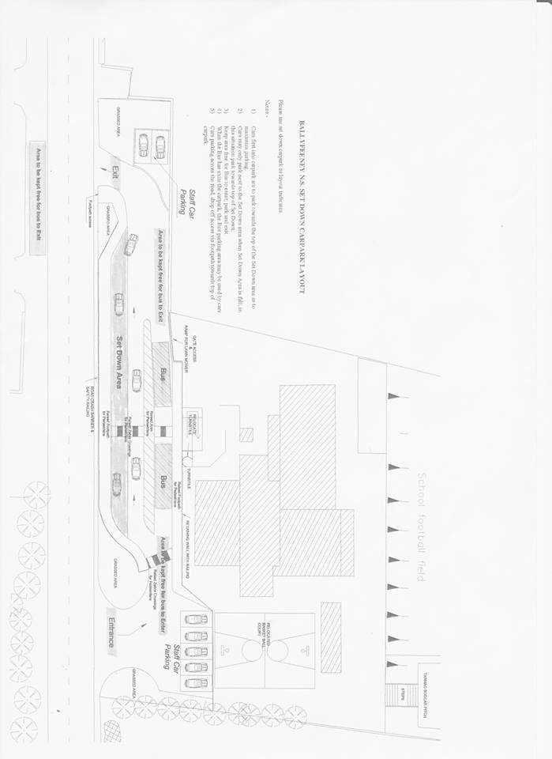When the bus has exited the car park, the bus parking area may be used

by cars.

1. Cars parking across the road, drop off access via footpath towards top of car park

Staff, Parents, Bus Drivers and Pupils are informed of rules regarding the operation and use of the car park and are provided with an explanatory map.

There are designated entry and exit points together with the relevant line markings on the ground and a clearly identified pedestrian crossing.

The space in front of the school to the left (Kilglass side) is reserved for the parking of staff cars only.

All users are asked to park in such a way as to leave maximum space available for other cars.

All users are asked to be particularly vigilant for pedestrians when driving up or down the avenue.

All persons who use the school car park, do so at their own risk.

**Application for school transport can be made online at www.buseireann.ie**

***Starting Primary School***

The child’s first year of school is mainly about settling into school, making friends, feeling happy and getting used to the school routine. On the learning side the emphasis is on getting children ready for learning by –

• Developing their oral language and expression.

• Sharpening their senses, especially seeing, hearing and touching.

• Developing physical coordination especially of hand and fingers.

• Extending their concentration span and getting them to listen attentively.

• Learning through play – the most enjoyable and effective way.

• Co-operating with the teacher and other children.

• Performing tasks by themselves.

• Working with others and sharing with them.

• Teaching each child to accept the general order, which is necessary for the class to work well.

**Before your child starts school**

You should ensure that he/she is as independent as possible - physically, emotionally and socially. If he/she can look after themselves in these areas your child will feel secure and confident and settle in readily. To make the transition as easy as possible please ensure they can:

• Button and unbutton their coat and hang it up.

• Use the toilet without help and manage trouser buttons. Please encourage personal hygiene and cleanliness. Remind your child of importance of flushing the toilet and washing his/her hands

• Use a tissue when necessary.

• Share toys and playthings with others and “take turns”.

• Tidy up and put away his/her playthings.

• Remain content for a few hours in the home of a relation, friend or neighbour. If he/she has had this experience, then separation from parent(s)/guardian(s) when your child starts school should not cause them any great anxiety.

**Giving your child a headstart**

There are lots of ideas and suggestions below as to how you can help your child.

**Oral Language Development**

Language is essential for developing reading and writing skills. It is important that a child’s ability to talk is as advanced as possible. It is through speech that children communicate their thoughts and feelings, needs and desires, curiosity and wonder.

Talk to your child naturally and casually about things of interest that you may be doing at home, in the shop, in the car, etc. Remember that children are constantly absorbing the language they hear around them. It takes them a while to make it their own and use it to express their needs.

Try to make time to listen when your child wants to tell you something that is important to him/her.

**Getting ready for learning**

There are many ways in which you can help prepare your child for learning:

* Talk to your children and encourage them to talk (Don’t use baby talk).
* Listen to them and what they have to say.

**Stories, reading and books**

* Read to your child regularly. Read and tell them stories, say nursery rhymes and poems, and encourage them to talk about what they hear (for example they could retell their favourite part of the story).

**Play in the Infant Classroom**

Play in the infant classroom is thinking time, language time, problem-solving time , memory time, planning time , investigating time and experimenting time for young children …….Therefore, play is a suitable learning context for English, Gaeilge, Maths , the Arts, SESE and SPHE.

Children love to play, and play often mirrors what is important in their lives. Play develops as children grow and change. Children play for different reasons. Sometimes they are exploring or learning new things…. Consolidating existing learning or practicing a skill. Play can also be a way of building or strengthening a relationship. *Children need time to develop their play.* (Aistear, Guidelines p.58).

**Aistear in the Primary School**

Aistear is used four times a week in the classroom. With the theme changing every four weeks some examples are The Post Office, The Vets, Space, The School, The Zoo. Children work in groups and move to a different play corner daily. Examples of Play Corners are Junk Art, Small World, Creativity, Construction, Playdough, Writing, Role Play, Sand and Water.

***Just Playing***

***Anita Wadley***

When I’m building in the block room,

Please don’t say I’m “Just Playing”

For you see , I’m learning as I play

About balances and shapes.

*Who knows , I may be an architect some day.*

When I’m getting all dressed up; setting the table , caring for the babies,

Please don’t get the idea I’m “Just Playing”

For, you see, I’m learning as I play;

*I may be a mother or father someday.*

When you see me sitting in a chair , reading to an imaginary audience.

Please don’t laugh and think I’m “Just Playing”

For , you see, I’m learning as I play;

*I may be a teacher someday.*

When you see me combing the bushes for bugs,

Or packing my pockets with choice things I find;

Don’t pass it off as “Just Play”.

For, you see, I’m learning as I play:

*I may be a scientist someday.*

When you see me engrossed in a puzzle or some “plaything” at my school,

Please don’t feel the time is wasted.

For, you see , I’m learning as I play.

I’m learning to solve problems and concentrate

*I may be in business someday.*

When you see me cooking or tasting foods,

Please don’t think that because I enjoy it , it is “Just Play”

I’m learning to follow directions and see differences.

*I may be a cook someday.*

When you see me learning to skip, hop , run , and move my body;

Please don’t say I’m “Just Playing”

For, you see,I’m learning as I play;

I’m learning how my body works.

*I may be a doctor , nurse or athlete someday.*

When you ask me , what I’ve done at school today,

And I say “I just played”; please don’t misunderstand me.

For, you see, I’m learning as I play.

I’m learning to enjoy and be successful in my work:

*I’m preparing for tomorrow.*

**Today, I am a child and my work is play.**

**Playing with your young child**

* Children learn through play and should be given lots of opportunities to: Act out roles i.e.-pretending to be someone else. Children love to pretend that they are nurses, doctors, shopkeepers etc. and such play activities enable them to use language.
* Play with objects such as sand, water, jigsaws, boxes and bricks and other toys.

**Remember**

1. Give your child time to play every day.
2. Provide things for your child to play e.g. Household items, recycled materials etc.
3. Join in the play. Be playful.
4. Make space for play.
5. When chatting, ask what your child was playing that day. Show that you value play whether it’s at home or in primary school

**Helping your child with Maths**

From birth your child has been learning about Maths. Maths is everywhere around us. Talking to your child and letting him or her take part in everyday activities like going to the shop, cooking, or even setting the table help your child to understand number, pattern and shapes, measuring and sorting.

Here are some tips on how you can play a key role in helping him/her to understand and enjoy Maths:

* Ask your child to help with sorting e.g. Matching socks or putting things in the fridge/press.
* Draw attention to the days of the week and time of the day e.g. tomorrow, yesterday, morning, night.
* Playing counting games: counting up and down the stairs, snakes and ladders or Bingo.
* Make patterns using buttons or clothes pegs. Think about pattern in colour, shape and size.
* Give your child maths objects to play with: measuring tapes, rulers, phones, old calendars and watches.

**Helping your child to read and write**

By speaking and listening to your child, by talking and reading to him and her, by pointing out words and notices at home or out and about you have introduced your child to the world of language - spoken and written.

Here are some tips on how you can help your child:

* Enjoy books together. Change the pages together, making connections between pictures and words. Ask the questions: What…..? When …? Why….? What if…..?
* Set up pretend play themes at home: a shop (food items, dress-up clothes, shoes , pretend cash register, pencil and paper)
* Enjoy cutting, gluing and sticking with your child
* Visit the library and choose, look at and talk about books together.

**Shared Reading:** Every Monday your child will bring home a library book.

On first reading Parent/Guardian reads book. Discuss front cover, pictures, ask questions

On second reading both child and Parent/Guardian read together.

On final reading child reads alone with help of Parent/Guardian

New Word Activities: Write new words on card. Make an extra copy and play snap.

Place all words in freezer bag, child chooses a word from bag and says word.

Find new words on page of reader…point to the word “the”,

Ask child “how many times can you see the word “sit”?

Ask child to find the word that rhymes with cat(hat).

Make sentences with individual words.

**Fine Motor Skills**

Fine motor skills involve the small muscles of the body that enable such functions as writing, grasping small objects, and fastening clothing. They involve strength, fine motor control and dexterity.

**How Fine Motor Skills Affect Learning and Living Skills:** These skills are important in most school activities as well as in life in general. Weaknesses in fine motor skills can affect a child’s ability to eat, write legibly, use a computer, turn pages in a book, and perform personal care tasks such as dressing and grooming.

**Things That Help Children to Improve Their Fine Motor Skills:**

* Play with play dough.
* Play with Lego, miniature cars, small blocks, action figures, and other small toys.
* Jigsaw puzzles.
* Play that involves using crayons, markers, scissors, and finger paints, as well as tearing paper.
* Play games that involve the handling of cards and small game pieces.
* Encourage your child to learn to manage such everyday skills as tying and lacing shoes and buttoning their own clothes.
* Practice writing with their fingers in, or on, different textures—shaving cream smeared on the table, play dough, clay, or sand.
* Beading activities – making patterns using beads and a shoelace.

**Tips for a smooth start to your child’s Initial Primary School Days**

For the first two weeks all children in Junior Infants will finish school at 12:00pm.

After these two weeks the new Junior Infants like all other pupils will arrive for school which starts at 9:20 a.m. and the Infant day will finish at 2:00p.m. It is very important that your child is both on time for school and collected on time after school every day.

Please note Infants must be collected at 2.00p.m. each school day. It is not possible for any infant to remain in school after 2pm so please make suitable arrangements for collection prior to the commencement of the school term. Please chat to your child about who will be collecting them from school.

A staff member will escort the pupils in the direction of the gate where children are met by the person collecting. This is to ensure that no child is left unsupervised. If there are any special collection arrangements please let us know by note in advance and discuss with your child.

Casually tell your children about school beforehand and talk about it as a happy place where there will be a big welcome and they will meet lots of new friends.

It helps to have the uniform and school bag ready each morning.

Please remember to have a name label on everything that your child owns. Please place this label on the front of books and copies.

It is also important to place **labels on pencils, twistables** as we gather a substantial amount of lost property on a daily basis.

**Please sharpen your child’s pencils and colouring pencils every night**.

If your child is more comfortable with shoes with Velcro straps then we would strongly recommend those. Laces can become undone quite regularly.

Please give your child a lunchbox which is easy to open and close and a drinks bottle which they can put the lid on securely by themselves.

*Please remember!*

Children need plenty of rest after the effort and excitement of a day at school. Try to ensure that your child goes to bed early and has a good night’s sleep.

Check bags/emails for notes re days off, planning days etc. Please read all letters carefully and keep for reference. We do not issue reminders.

Text-a-Parent – on occasion texts may be sent instead of notes/emails.

**If your mobile number or address changes, please ensure that you inform the school Secretary immediately.**

***From all the staff at Ballyfeeney***

We hope you found this booklet helpful and we hope your child will enjoy their Primary Education in Ballyfeeney NS where they “learn in a happy and safe environment, feel valued, respected and are encouraged to do their best”

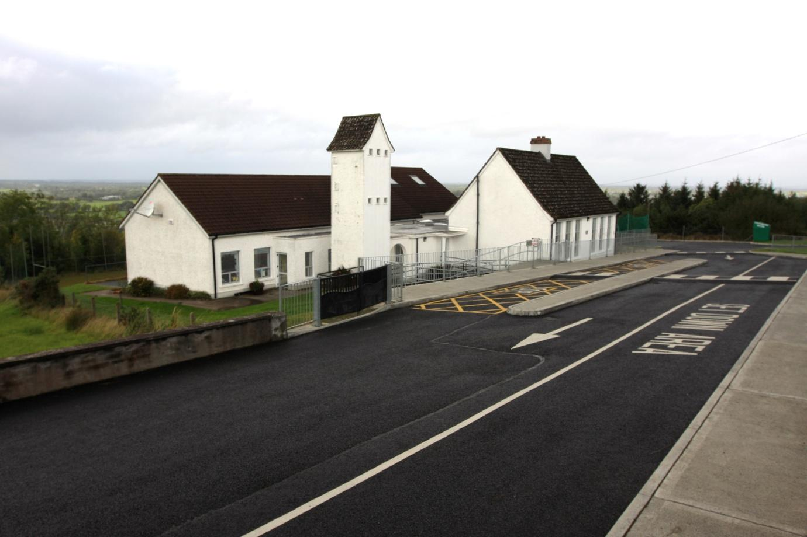

**The Sculptors**

I dreamed I stood in a studio

And watched two sculptors there.

The clay they used was a young child’s mind,

And they fashioned it with care.

One was a teacher, the tools he used

Were books and music and art;

One was a parent with a guiding hand

And a gentle, loving heart.

Day after day the teacher toiled

With touch that was deft and sure,

While the parent laboured by his side

And polished and smoothed it o’er.

And when at last their task was done,

They were proud of what they had wrought;

For the things they had moulded into a child,

Could neither be sold nor bought.

And each agreed they would have failed

If they had worked alone,

For behind the parent stood the school,

And behind the teacher, the home.

Anonymous

