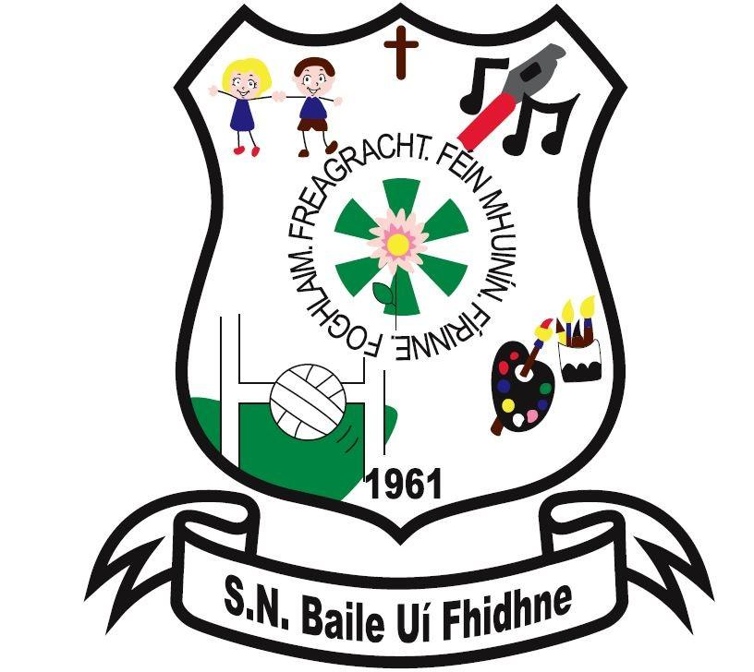

Ballyfeeney NS Code of Conduct

for Parent(s)/Guardian(s)

Scramogue

Co Roscommon

F42 WV63

Tel:0719633855

Email:[ballyfeeneyns@gmail.com](mailto:ballyfeeneyns@gmail.com)

This Code of Conduct Policy for Parent(s)/Guardian(s) was drawn up by the staff and Board of Management of Ballyfeeney N.S. in consultation with parents.

The Board of Management is committed to ensuring the health and safety of the pupils and teachers of the Ballyfeeney National School, and also ensuring that the teaching and learning process in the school is not significantly disrupted.

It is agreed that a high standard of behaviour requires a strong sense of community within the school and a high level of co-operation among staff and between staff, parents and pupils.

All the stakeholders aim to work for the benefit of the child and their learning.

Positive and respectful communication is of high importance to our school. This not only extends to the children but to all of the stakeholders e.g. the staff, parents and the wider community.

Anyone entering our building should feel safe to do so. While the behaviour of children in our school is of vital importance, adults in the school community also have a responsibility to ensure their own behaviour models the types of behaviour expected of children.

It is important that all stakeholders are responsible for their own behaviours in the school.

On enrolment of your child at Ballyfeeney NS parents/guardians are expected to adhere to this code and all policies in our school. Parents are requested to familiarize themselves with school policies and to co-operate with the school with regard to their implementation.

Parent(s)/Guardian(s) are expected to

* Develop close links with the school, nurturing a positive attitude towards school.
* Collaborate with the school in developing the full potential of their children.
* Share the responsibility of seeing that the school remains true to its ethos, values and distinctive character.
* Become actively involved and support the school/parent association.
* Participate in policy and decision-making processes.
* Ensure your child understands and follows all school policies particularly the School’s Code of Behaviour, Anti Bullying, and Acceptable Use Policies and help your child learn and practice good behaviour and develop positive attitudes towards self, others and school.
* Ensure your children attends school in full uniform (no stripes/logos, note to be provided if for some reason it cannot be worn) and are punctual adhering to school times: Opening Times: 9:20am, Closing Times: 2pm(Infants), 3pm (1st-6th). Ensure your children are not on the school grounds outside of school hours in the interests of personal safety. The insurance company has advised us that no responsibility can be accepted for pupils who arrive early or children who are still on the school grounds after 3:00p.m.
* Ensure your children are equipped with all school books and supplies prescribed by their class teacher. All books should be kept in good condition, covered and present in school with the child on the first day of the new school term.
* Ensure your children wear appropriate clothing for the weather, that they will be warm and dry during break and lunch time.
* Ensure your children have a sufficient healthy lunch in line with our school’s Healthy Eating policy noting that the following are not permitted (Crisps (including crisp-style snacks)**,** Fizzy drinks (including fizzy fruit-flavoured water, juices, etc), Sweets**,** Chocolate biscuits/bars**,** Cereal bars **,** Chewing gum **,** Fruit winders, Popcorn)

Do not send any foods containing nuts to school as we have a number of pupils attending our school who have nut allergies.

Only give your child something you feel that they can manage easily themselves. If sending fruit please ensure it is peeled.

Lunch must be stored in a hard plastic lunch box that your child can open independently.

If your child is bringing a yoghurt make sure you give them a spoon.

Do not send frubes to school as there can be many accidents.

If your child has a drinks bottle make sure they can open it independently.

* We are a green school, with this in mind, children are also asked to take home (in lunchbox) all uneaten food, silver paper, wrappings, peelings, containers and cartons.

* Ensure no toys, cans and glass or other dangerous objects are sent to school.
* Be courteous and respectful towards pupils and staff. Behaviour that interferes with the rights of others to learn/teach and to feel safe is unacceptable.
* Respect school property and encourage your children to do the same.
* Label pupils coats and other personal property.
* Strictly supervise pre-school children, while on the school grounds.
* Ensure money, if required, is in a sealed envelope with the pupil’s name and details of payment clearly written on the outside of the envelope.
* Ensure your child does not carry a mobile phone. If your child’s mobile is confiscated, contact the class teacher to arrange a suitable time for the phone to be returned. Please note it is illegal for a child under 13 to register with and use many social media networks, including Facebook, Instagram and Snapchat.
* Communicate regularly with the school about factors likely to affect the behaviour of their children. It is vital that the school is immediately informed if family events/situations occur that cause anxiety to the child and therefore may adversely affect her education.
* Inform the class teacher if your child is absent/late for school or departing early and the reason why.

It is school policy that reasons must be given in writing. *The school must notify Túsla if a child is absent for 20 days or more in the school year, even if those absences are accounted for by letter****.*** Absences will be categorised into Unexplained, Illness, Urgent Family Reason etc.

* Ensure your child does their homework to the best of their individual ability. Ideally homework should be done soon after school while your child is still fresh and never in the morning before school. Check and sign a child’s homework journal/sheet every evening.
* Try to ensure that your child goes to bed early and has a good night’s sleep.
* Inform the school secretary immediately if your mobile number or address changes.
* Inform the school if your child has a specific medical condition or allergies which requires a special diet (Administration of Medicines Policy).
* Where head lice is detected, treat immediately and notify the school as soon as possible, confidentiality is assured.
* Check bags/emails for notes re days off, planning days etc. Please read all letters carefully and keep for reference. We do not issue reminders. Text-a-Parent – on occasion texts may be sent instead of notes/emails.
* When using the car park, use it in such a way as to leave maximum space available for other cars, be patient and vigilant, particularly for pedestrians when driving up or down the avenue. Show consideration and an awareness of the safety of all children attending this school particularly at drop off and collection times.
* Support our school community (staff, parents and students) with the education and wellbeing of your child. If, at any time, you feel there are issues regarding your child you should speak with the relevant teacher. Please note that teachers are responsible for students during class time, we do not have surplus staff to supervise. Contact the school secretary or send a note in your child’s homework journal if you wish to consult with a teacher.
* Participate in meetings in a positive and respectful manner, affirming the professional role of the staff and all staff members in the school.
* Co-operate with teachers in instances where your child’s behaviour may be impacting on the wellbeing and educational progress of others.
* Respect that the time of meetings should be kept to a reasonable amount of time. Times of meetings should be agreed beforehand and these should be respected.
* Do not ask staff to speak about another parent’s child. The staff of the school will respect your child’s right to privacy so it is asked that parents respect other children’s rights to privacy.
* In all matters pertaining to the wellbeing and education of pupils, only parents/legal guardians named on the enrolment form will be consulted by staff, no discussions will take place with other family members/friends dropping off or collecting pupils.

* For general queries please consult our website or contact our school secretary who is available to take calls from 9am-12 daily.

* Should you wish to make a complaint then you are advised to follow the school’s Parental Complaints Procedure.
* Refrain from discussing school business, children attending this school or members of staff in an inappropriate or offensive manner in any public forum including social media sites. As a school, we cannot condone the use of social media to criticise and make comments about the school, its pupils or any members of staff, or any member of the school community. Our school values its good name and as a school community we will protect and uphold that good name. Instances where defamatory comments are made which tarnish, or bring into disrepute this school or any member of the school community (whether named or implied) will be taken very seriously. The right to one's good name is protected under the Constitution of Ireland (Article 40.3.2) and the Defamation Act 2009.

* The taking of photographs and/or filming and/or recording without permission is strictly prohibited.

* All stakeholders are expected to speak to each other with respect. Offensive language, swearing and threats will not be tolerated. Shouting or other aggressive tones are not acceptable. If a stakeholder displays anger or aggression to another member of the school community, they may be asked to remove themselves from the building or in the case of a phone call it will be ended. In certain cases, the Gardaí must be called.
* As the Board of Management is responsible for the Health & Safety of all staff and students, parents must not approach or reprimand another person’s child on the school premises.

We endeavour to set the best example at Ballyfeeney N.S. ensuring our pupils enjoy their Primary Education where they “learn in a happy and safe environment, feel valued, respected and are encouraged to do their best” All stakeholders are expected to treat our pupils and staff with the utmost respect.

The family and home are central to the social and intellectual development of the child and the nurturing of good, moral values. The school and the family strive to be mutually supportive and respectful of each other, so that the child’s education can be effective.

Ratification__________________________Date: ___________________