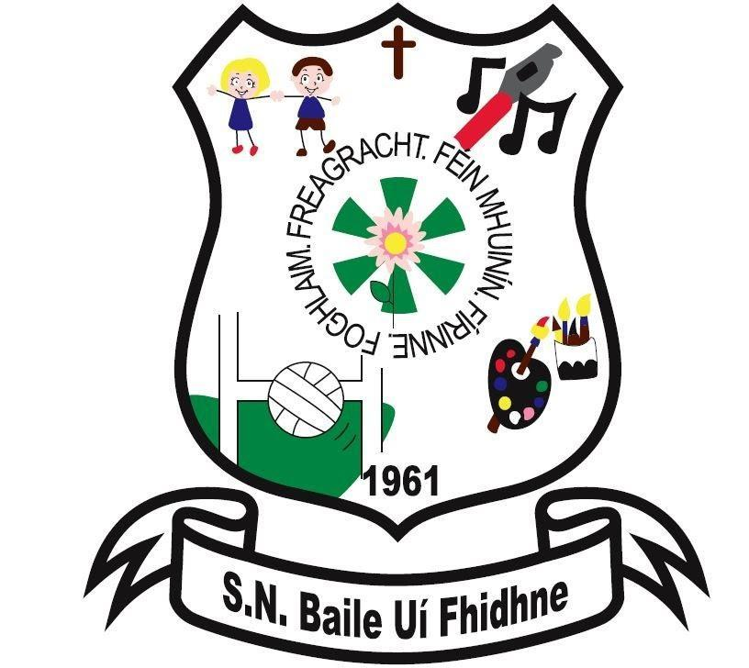

Parents as Partners Policy

Ballyfeeney NS

Scramogue

Co Roscommon

F42 WV63

Tel:0719633855

Email:[ballyfeeneyns@gmail.com](mailto:ballyfeeneyns@gmail.com)

Ballyfeeney National School

**Parent as Partners Policy**

**INTRODUCTORY STATEMENT:**

This Policy was drawn up by the staff and Board of Management of Ballyfeeney NS in consultation with parents. Its purpose is to provide information and guidelines to parents and staff on parent/staff meetings and communication in Ballyfeeney NS.

The family and home are central to the social and intellectual development of the child and the nurturing of good, moral values. The school and the family strive to be mutually supportive and respectful of each other, so that the child’s education can be effective. All the stakeholders aim to work for the benefit of the child and their learning.

**PARENTS ARE ENCOURAGED TO:**

* Develop close links with the school
* Participate in meetings in a positive and respectful manner, affirming the professional role of the staff and all staff members in the school
* Collaborate with the school in developing the full potential of their children
* Share the responsibility of seeing that the school remains true to its ethos, values and distinctive character
* Become actively involved in the school/parent association
* Participate in policy and decision-making processes affecting them

**STAFF ARE ENCOURAGED TO:**

* Establish good communication with parents/guardians of pupils in their class
* Keep parents/guardians informed of their child’s progress and behaviour both positive and negative
* Listen to what parents/guardians have to say and encourage them to bring any concerns to you at an early stage to avoid situations escalating
* Be aware of the role of parents/guardians as prime educators and emphasise that all parties are working together for the child’s benefit to help him/her reach his/her potential
* Value and respect the input of parents as they know their child best.

**STRUCTURES IN PLACE TO FACILITATE OPEN COMMUNICATION & CONSULTATION WITH PARENTS:**

* When possible GP Hall is set up to facilitate parents for coffee mornings, meetings, courses etc
* Parent/teacher meetings one-to-one in November
* Parents receive school report of each pupil at the end of each school year
* Meetings with parents whose children have special needs with SET
* Consultation throughout the year
* Written communication
* Through the parent’s association, parents are invited to discuss and contribute to the drafting and review of school policies.
* Regular notifications and the school website keep parents up-to-date with school events, holidays and school concerns
* Homework diary 1st – 6th class, used to relay messages which are signed between parents and teachers. Parents requested to sign diary each night to certify that homework has been completed
* Parents are invited to share their expertise with their child’s class in a structured way
* When possible, Parents are invited to events throughout the year e.g. Blue Star/Green Flag celebrations, school masses, carol services and school concerts
* Involvement of parents in the relevant activities.

If a parent wishes to consult with a teacher, he/she can contact the school secretary to arrange a suitable time.

**It is vital that the school is immediately informed if family events/situations occur that cause anxiety to the child and therefore may adversely affect her education.**

In all matters pertaining to the wellbeing and education of pupils, only theparents/legal guardians named on the enrolment form will be consulted by staff.

**PARENT/TEACHER MEETINGS:**

Formal Parent/Teacher meetings will be held once a year for all classes (Circular 14/04).

Where possible they will be held in the first term, towards the end of November for all classes. They will be initiated by the school staff and details regarding time, etc will be worked out by the class teacher, in consultation with parents. The school will attempt to co-ordinate times where siblings are concerned. Meetings may take place in classrooms and resource rooms. The teachers use prepared guidelines for the meetings and collaborate in advance about the progress of individual children.

**THE PURPOSE OF THE PARENT/TEACHER MEETING IS:**

* To establish and maintain good communication between the school and parents
* To let parents know how their children are progressing in school
* To help teachers/parents get to know the children better as individuals
* To help children realise that home and school are working together
* To meet demands for accountability
* To share all positives about the child
* To share with the parent the problems and difficulties the child may have in school
* To review with the parent the child’s experience of schooling
* To learn more about the child from the parent’s perspective
* To learn more about parental opinions on what the school is doing
* To identify areas of tension and disagreement
* To identify ways in which parents can help their children
* To negotiate jointly decisions about the child’s education
* To inform the parents of standardised test results

*Circular 56/2011 Initial Steps in the implementation of the national literacy and numeracy Strategy* has been adopted by the Board of Management. References to parent/school communication are:

**REPORTING TO PARENTS:**

Parents have the primary responsibility for their children’s learning and development. Schools can strengthen the capacity of parents to support their children in this way by sharing meaningful information about the progress that their children are achieving in the education system. This information needs to draw on the different sources of evidence that staff use, such as conversations with the learner, data-collection and documented progress on objectives and milestones reached in their short and long-term planning, examination of students own self-assessment data, documented observations of the learners engagement with tasks, outcomes of other assessment tasks and tests, and examples of students work. In turn, parents will often be able to enrich staff’s knowledge of their students’ progress through providing further information about the students' learning at home.

**REPORT CARD TEMPLATES:**

Schools should help parents to understand fully the evidence of learning that the school reports to them, especially information from any standardised tests. The NCCA has provided a range of standard report templates to assist schools in reporting information about the progress of primary pupils to parents, including information from standardised tests. The NCCA report card templates were developed through a process of consultation with schools and parents can take account of research commissioned by the NCCA.

**THE REPORT CARDS PROVIDE FOR REPORTING IN FOUR KEY AREAS:**

* The child’s learning and achievement across the curriculum
* The child’s learning dispositions
* The child’s social and personal development
* Ways in which parents can support their child’s learning

Ballyfeeney NS uses standard report card templates for reporting to parents on students’ progress and achievement at school.

**FORMAL MEETINGS:**

Formal timetabled parent/teacher meetings take place in November. However, if a parent wishes to arrange a meeting at any stage during the year to discuss their child, they may do so by prior appointment.

* All communication sent from the school will be sent to the child’s home address as given on the enrolment form or by email/text as provided.
* In the case of separated parents, requests can be made by both parents to meet their child’s teacher(s) individually for parent/teacher meetings

**FORMAL MEETINGS-IEP’S:**

Formal timetabled parent/staff meetings on the subject of the **Individual Education Plan** will take place in September/October and again in February. However, if a parent wishes to arrange a meeting at any stage during the year to discuss their child, they may do so by prior appointment.

**INFORMAL PARENT/STAFF MEETINGS:**

* The School encourages communication between parents and staffs
* Meetings with the class teacher at the classroom door to discuss concern is discouraged on a number of grounds:
  1. Staff cannot adequately supervise a class while at the same time speaking to a parent
  2. It is difficult to be discreet when so many children are standing close by
  3. It can be embarrassing for a child when his/her parent is talking to staff at a classroom door

Occasions occur where a parent needs to speak to a staff member urgently. Sometimes these meetings need to take place without prior notice. The teacher will aim to facilitate such meetings making every effort to ensure that the children in the class do not lose out on any of the teaching/learning time.

**COMPLAINTS PROCEDURE:**

Complaints are infrequent, but the school would wish that these would be dealt with informally, fairly and quickly. .

The following complaints procedure has been drawn up by the Board of Management and is in accordance with the agreement reached in 1993 between the INTO and CPSMA for dealing with complaints by parents against teachers in areas where the Board has jurisdiction as provided for in the above Agreement. The purpose of this policy is to facilitate the resolution of difficulties where they may arise in an agreed and fair manner. In this agreement ‘days’ means school days. Only those complaints about teachers which are **written and signed** by parents/guardians of pupils may be investigated formally by the Board of Management.

**Five stages** are to be followed in progressing a complaint and the specific timescale to be followed at each stage.

**Stage 1**

1. A parent/guardian who wishes to make a complaint should approach the class teacher with a view to resolving the complaint.
2. Where the parent/guardian is unable to resolve the complaint with the class teacher she/he should approach the Principal with a view to resolving it.
3. If the complaint is still unresolved, the parent/guardian should raise the matter with the Chairperson of the Board of Management with a view to resolving it.

**Stage 2**

1. If the complaint is still unresolved and the parent/guardian wishes to pursue the matter, she/he should lodge the complaint in writing with the Chairperson of the Board of Management.
2. The Chairperson should bring the precise nature of the written complaint to the notice of the teacher and seek to informally resolve the matter between the parties within 5 days of receipt of the written complaint.

**Stage 3**

If the complaint is not resolved informally, the Chairperson should:

1. Supply the teacher with a copy of the written complaint
2. Arrange a meeting with the teacher and, where applicable, the Principal with a view to resolving the complaint.

Such a meeting should take place within 10 days of receipt of the written complaint.

**Stage 4**

1. If the complaint is still not resolved, the Chairperson should make a formal report to the Board within 10 days of the meeting referred to in 3(b) above
2. If the Board considers that the complaint is not substantiated, the teacher and the complainant should be so informed within 3 days of the Board meeting.
3. If the Board considers that the complaint is substantiated or that it warrants further investigation, it proceeds as follows:
4. The teacher should be informed that the investigation is proceeding to the next stage.
5. The teacher should be supplied with a copy of any written evidence in support of the complaint.
6. The teacher should be requested to supply a written statement to the Board in response to the complaint.
7. The teacher should be afforded an opportunity to make a presentation of his/her case to the Board. The teacher would be entitled to be accompanied and assisted by a friend at any such meeting.
8. The Board may arrange a meeting with the complainant if it considers such to be required. The complainant would be entitled to be accompanied and assisted by a friend at any such meeting.
9. The meeting of the Board of Management referred to in 4(d) and (e) will take place within 10 days of the meeting referred to in 3(b).

**Stage 5**

1. When the Board has completed its investigation, the Chairperson should convey the decision of the Board in writing to the teacher and the complainant within 5 days of the meeting of the Board.
2. The decision of the Board is final.

This Complaints Procedure by Parents against Teachers has been prepared based on the conditions existing in the school at the time of writing. It may be altered, revised or updated to comply with any changes in conditions, statutory requirements or any suggestions from the partners in Education. It has been compiled following the guidelines issued by the INTO and CPSMA.

**BEHAVIOUR OF ALL STAKEHOLDERS IN THE SCHOOL:**

Positive and respectful communication is of high importance to our school. This not only extends to the children but to all of the stakeholders e.g. the staff, parents and the wider community.  Anyone entering our building should feel safe to do so. While the behaviour of children in our school is of vital importance, adults in the school community also have a responsibility to ensure their own behaviour models the types of behaviour expected of children.

It is important that all stakeholders are responsible for their own behaviours in the school.  Examples include:

* All stakeholders are expected to speak to each other with respect. Shouting or other aggressive tones are not acceptable.  If a stakeholder displays anger or aggression to another member of the school community, they may be asked to remove themselves from the building.  In certain cases, the Gardaí must be called
* All stakeholders will treat our children with the utmost respect while on the premises
* Staff should not be asked to speak about another parent’s child. The staff of the school will respect your child’s right to privacy so it is asked that parents respect other children’s rights to privacy
* When stakeholders meet, it is important to respect that the time of meetings should be kept to a reasonable amount of time. Times of meetings should be agreed beforehand and these should be respected
* Staff are generally available to listen to a quick issue in the morning and after school. However, should a parent need to have a discussion or meeting, an appointment should be made at a convenient time for both parties. This ensures that issues can be resolved. Classes begin at 9:20 am and finish at 3:00pm and this time should not be interrupted.

**PARENTS ARE EXPECTED TO:**

* Ensure their children attend school and are punctual
* Equip pupils with appropriate school materials, a sufficient healthy lunch and full uniform
* Be courteous towards pupils and staff
* Make an appointment to meet with a teacher/the Principal through the office
* Respect school property and encourage their children to do the same
* Label pupils coats and other personal property
* Strictly supervise pre-school children, when in the school.
* As the Board of Management is responsible for the Health & Safety of all staff and students, parents are requested not to approach or reprimand another person’s child on the school premises.

**SAFETY, HEALTH AND WELFARE AT WORK:**

The Safety, Health and Welfare at Work Act became operative on 1 November 1989. It is an important piece of legislation for the BOM and for those who work in schools, as schools and colleges were brought under the scope of safety legislation for the first time.

It is recognised that school staff may be at risk from violence in the form of verbal abuse, threats, assaults or other forms of intimidation. This behaviour may come from pupils, parents, guardians, other staff members or intruders.

In this respect, all staff should be aware of **DES Circular 40/97** which deals with the procedures to follow if they feel they have been subjected to any of the above behaviours.

**SOCIAL MEDIA – REFERENCES TO OUR SCHOOL, STAFF AND STUDENTS**

As a school, we encourage you to support our school community (staff, parents and students) with the education and wellbeing of your child. If, at any time, there are issues regarding your child you should speak with the relevant teacher. Should you wish to make a complaint then you are advised to follow the school’s Parental Complaints Procedure.

You are expected to refrain from discussing school business, children attending this school or members of staff in an inappropriate or offensive manner in any public forum including social media sites. As a school, we cannot condone the use of social media to criticise and make comments about the school, its pupils or any members of staff, or any member of the school community.

Our school values its good name and as a school community we will protect and uphold that good name. Instances where defamatory comments are made which tarnish, or bring into disrepute this school or any member of the school community (whether named or implied) will be taken very seriously. The right to one's good name is protected under the Constitution of Ireland (Article 40.3.2) and the Defamation Act 2009.

Ballyfeeney N.S and each family strive to be mutually supportive and respectful of each other, so that the child’s education can be effective. All the stakeholders aim to work for the benefit of the child and their learning.

**Ratified by the Board of Management**

**Chairperson: ______________________________**

**Date: _____________________________________**