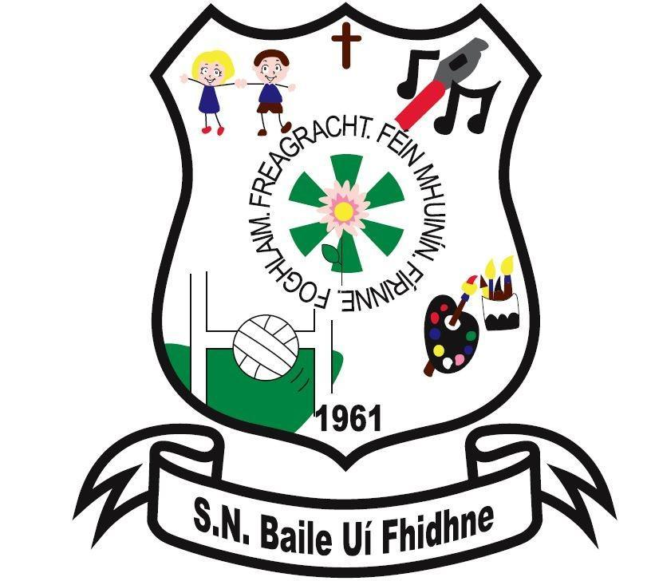

Home School Links

Ballyfeeney NS

Scramogue

Co Roscommon

F42 WV63

Tel:0719633855

Email:[ballyfeeneyns@gmail.com](mailto:ballyfeeneyns@gmail.com)

**Ballyfeeney National School**

**Home-School Links**

**(Please also refer to Parent as Partners Policy)**

**General**

The following measures endeavour to develop and ensure dynamic and supportive links between school and home.

1. School Information Booklet on website
2. Homework notebook and notes to parents
3. Parent-Teacher Meetings
4. End of year reports
5. Appointment procedure for meeting parents where necessary
6. Phone calls where necessary
7. Religious ceremonies
8. Meetings involving parents
9. School plays, fundraising events etc.
10. Sports day
11. Parent’s Association activities
12. See Saw App
13. Text-a-Parent(Aladdin)
14. School email
15. School Website

Parents(s)/Guardian(s) are asked not to contact staff about school related matters through social media, Facebook, messenger, Instagram etc.

## **Policy**

It is recognised that good home-school links contribute greatly to the quality of education received by children. To establish these links an open, cordial relationship exists between parents and teachers which recognises and values the respective roles of each.

# **Aims**

1. To facilitate a communicative relationship between teachers and parents to the benefit of our pupils.
2. To establish procedures for the sharing of information in relation to pupil’s progress.
3. To create a school environment where parents and guardians feel welcome and free to discuss their child’s progress with the teachers.
4. To encourage all parents to become involved with the Parent’s Association.

# **Communications**

When possible Formal Parent-Teacher meetings will be held every year in November where each parent may have a private meeting with their child’s teacher(s). The meetings will be held during the hours laid down by the DES. Where parents are unable to attend at this time, they are encouraged to make an alternative appointment with the teacher at a mutually suitable time.

The school also encourages periodical informal meetings between teachers and parents which may be initiated by either party as they see fit.

Parents will be encouraged to be familiar with the work being done by their child in school and to be aware of what homework is being done. A formal school report will be issued at the end of each school year.

Information on school activities will be communicated to parents through periodic letters, emails and bulletins during the year, use of Text-a-Parent and See Saw App.

In accordance with the Educational Welfare Act (2000), explanatory notes on pupil absences must be sent to the class teacher after each absence.

At the teacher’s discretion, and subject to the principal’s approval, parents may be invited to use their expertise in a particular area to assist the teacher in some classroom-based or extra-curricular activities. Garda Vetting requirements will be fulfilled prior to such arrangements.

# **Parents’ Association**

The school recognises the benefits of an active Parent’s Association. The association may communicate with the school through meetings between the chairperson/secretary and the Principal and Deputy Principal, particularly after a Parent’s Association general or committee meetings.

At each of the B.O.M. meetings during the year, one item on the agenda will be the parent’s representative’s report which allows for two-way communication between the board and parent body. The Parent’s Association support in the provision of resources, financial support and assistance in extra-curricular areas is welcome and appreciated.

# **Roles and Responsibilities**

It is important that all partners in the school community be aware of the parameters of their own and other’s respective roles and responsibilities. The school ethos must be upheld at all times. The ethos is defined by the patron. The school is Christian, child-centred, non-discriminatory and democratic. Consequently, respect for the partners – children, parents, staff and management – must be shown at all times.

Please also refer to Parents as Partners Policy

Signed on behalf of the Board of Management

_____________________________________ Date: ________________

Chairperson, BoM