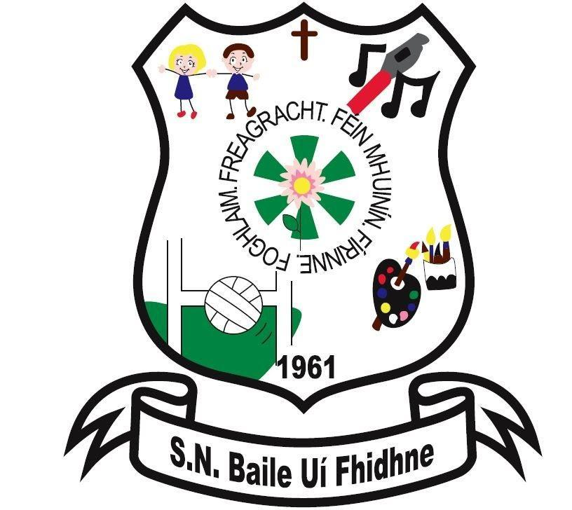

Policy on Car Parking

Ballyfeeney NS

Scramogue

Co Roscommon

F42 WV63

Tel:0719633855

Email:[ballyfeeneyns@gmail.com](mailto:ballyfeeneyns@gmail.com)

**Ballyfeeney NS**

**Car Parking**

Staff, Parents, Bus Drivers and Pupils are informed of rules regarding the operation and use of the car park and are provided with an explanatory map.

There are designated entry and exit points together with the relevant line markings on the ground and a clearly identified pedestrian crossing.

The space in front of the school to the left (Kilglass side) is reserved for the parking of staff cars only.

All users are asked to park in such a way as to leave maximum space available for other cars.

All users are asked to be particularly vigilant for pedestrians when driving up or down the avenue.

All persons who use the school car park, do so at their own risk.

_____________________________Date____________________

Chairperson, BOM