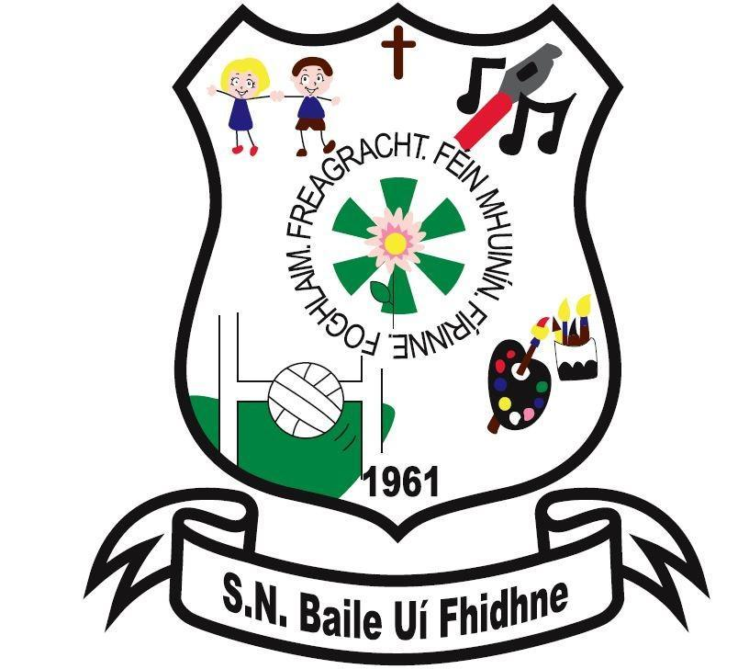

Complaints Procedure against Teachers Policy

Ballyfeeney NS

Scramogue

Co Roscommon

F42 WV63

Tel:0719633855

Email:[ballyfeeneyns@gmail.com](mailto:ballyfeeneyns@gmail.com)

# 

# Ballyfeeney National School

**COMPLAINTS PROCEDURE BY PARENTS AGAINST TEACHERS POLICY**

**Introduction**

The following complaints procedure has been drawn up by the Board of Management and is in accordance with the agreement reached in 1993 between the INTO and CPSMA for dealing with complaints by parents against teachers in areas where the Board has jurisdiction as provided for in the above Agreement. The purpose of this policy is to facilitate the resolution of difficulties where they may arise in an agreed and fair manner. In this agreement ‘days’ means school days. Only those complaints about teachers which are **written and signed** by parents/guardians of pupils may be investigated formally by the Board of Management.

**Five stages** are to be followed in progressing a complaint and the specific timescale to be followed at each stage.

**Stage 1**

1. A parent/guardian who wishes to make a complaint should approach the class teacher with a view to resolving the complaint.
2. Where the parent/guardian is unable to resolve the complaint with the class teacher she/he should approach the Principal with a view to resolving it.
3. If the complaint is still unresolved, the parent/guardian should raise the matter with the Chairperson of the Board of Management with a view to resolving it.

**Stage 2**

1. If the complaint is still unresolved and the parent/guardian wishes to pursue the matter, she/he should lodge the complaint in writing with the Chairperson of the Board of Management.
2. The Chairperson should bring the precise nature of the written complaint to the notice of the teacher and seek to informally resolve the matter between the parties within 5 days of receipt of the written complaint.

**Stage 3**

If the complaint is not resolved informally, the Chairperson should:

1. Supply the teacher with a copy of the written complaint
2. Arrange a meeting with the teacher and, where applicable, the Principal with a view to resolving the complaint.

Such a meeting should take place within 10 days of receipt of the written complaint.

**Stage 4**

1. If the complaint is still not resolved, the Chairperson should make a formal report to the Board within 10 days of the meeting referred to in 3(b) above
2. If the Board considers that the complaint is not substantiated, the teacher and the complainant should be so informed within 3 days of the Board meeting.
3. If the Board considers that the complaint is substantiated or that it warrants further investigation, it proceeds as follows:
4. The teacher should be informed that the investigation is proceeding to the next stage.
5. The teacher should be supplied with a copy of any written evidence in support of the complaint.
6. The teacher should be requested to supply a written statement to the Board in response to the complaint.
7. The teacher should be afforded an opportunity to make a presentation of his/her case to the Board. The teacher would be entitled to be accompanied and assisted by a friend at any such meeting.
8. The Board may arrange a meeting with the complainant if it considers such to be required. The complainant would be entitled to be accompanied and assisted by a friend at any such meeting.
9. The meeting of the Board of Management referred to in 4(d) and (e) will take place within 10 days of the meeting referred to in 3(b).

**Stage 5**

1. When the Board has completed its investigation, the Chairperson should convey the decision of the Board in writing to the teacher and the complainant within 5 days of the meeting of the Board.
2. The decision of the Board is final.

This policy has been prepared based on the conditions existing in the school at the time of writing. It may be altered, revised or updated to comply with any changes in conditions, statutory requirements or any suggestions from the partners in Education. It has been compiled following the guidelines issued by the INTO and CPSMA.

Signed: ________________________

Chairperson, Board of Management