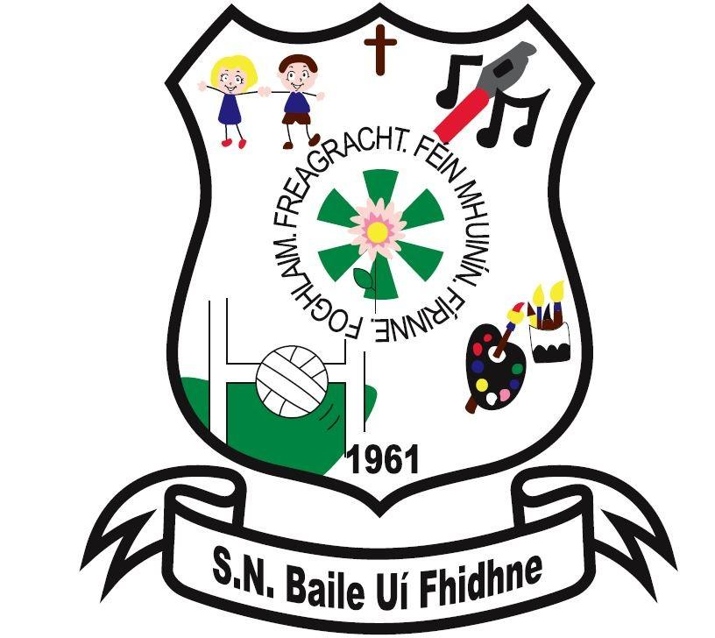Ballyfeeney NS Health and Safety Policy

Scramogue

Co Roscommon

F42 WV63

Tel:0719633855

Email:[ballyfeeneyns@gmail.com](mailto:ballyfeeneyns@gmail.com)

In accordance with the Safety, Health and Welfare at Work Act 2005 and associated legislation together with the Health and Safety Authority’s *“Guidelines on Managing Safety, Health and Welfare in Primary Schools”*, the school’s safety policy and health and safety statement was reviewed by the Board of Management in May 2020 . It is the policy of the

Board of Management of Ballyfeeney National School to ensure, so far as is reasonably practicable, the safety, health and welfare at work of all employees and to protect pupils, visitors, contractors and other persons at the school from injury and ill health arising from any work activity. The successful implementation of this policy requires the full support and active co-operation of all employees, parents, pupils, contractors and visitors to the school. It is recognized that hazard identification, risk assessment and control measures are legislative requirements which must be carried out by the employer to ensure the safety, health and welfare of all employees.

The Board of Management, as employer, undertakes, in so far as is reasonably practicable, to:

* Promote standards of safety, health and welfare that comply with the provisions and requirements of the Safety, Health and Welfare at Work Act 2005 and other relevant legislation, standards and codes of practice;
* Maintain a constant and continuing interest in safety, health and welfare matters pertinent to the activities of the school.
* Manage and conduct school activities so as to ensure the safety, health and welfare of employees
* Prevent improper conduct or behaviour likely to put employees and others safety, health and welfare at risk
* Provide the necessary resources to ensure the safety, health and welfare of all those to whom it owes a duty of care, including employees, pupils, contractors and visitors.
* Provide information, instruction, training and supervision where necessary to enable employees, to perform their work safely and effectively.
* Consult with employees on matters related to safety, health and welfare at work

The Board of Management is committed to playing an active role in the implementation of this safety, health and welfare policy and undertakes to review and revise it in light of changes in legislation, experience and other relevant developments.

Signed:

_____________________________

Chairperson,

Board of Management

Ballyfeeney National School

Date: