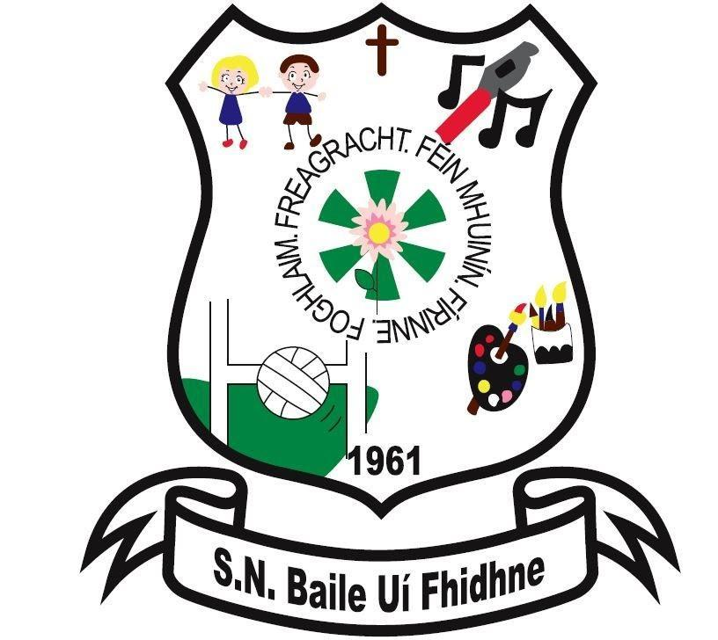

Healthy Eating Policy

Ballyfeeney N.S.

Scramogue

Co Roscommon

F42 WV63

Tel:0719633855

Email:[ballyfeeneyns@gmail.com](mailto:ballyfeeneyns@gmail.com)

**Ballyfeeney National School**

**Healthy Eating Policy**

At Ballyfeeney National School we encourage children to eat a nutritious lunch.

As part of the Social, Personal and Health Education (SPHE) Programme, at Ballyfeeney National School we encourage the children to become more aware of the need for healthy food in their lunch boxes.

What people eat is known to be a key factor influencing health. Research indicates a strong link between diet and performance (e.g. a low sugar intake promotes concentration, lessens hyperactivity, protects teeth, and lessens the risk of diabetes. A low salt intake reduces the risk of heart disease in later life).

To promote healthy eating habits in our school, we introduced a healthy eating policy in September 2010. This policy was revised in September 2020 with the introduction of a revised food pyramid and also due to a number of pupils enrolled in our school who have nut allergies.

Each class teacher encourages the pupils to eat their lunch but it is ultimately the child’s responsibility.

**Aims**

1. To promote the personal development and well-being of the child

2. To promote the health of the child and provide a foundation for healthy living in all its aspects.

**Objectives**

1. To enable the child to appreciate the importance of good nutrition for growing and developing and staying healthy

2. To enable the child to accept some personal responsibility for making wise food choices and adopting a healthy, balanced diet.

Lunch is an important meal for school-going children. It should provide one third of their recommended daily allowance of nutrients without being high in fat, sugar or salt. It should also provide dietary fibre.

The traditional packed lunch of milk and sandwiches is under attack from a range of convenience foods like crisps, sweets, biscuits, chocolate and soft drinks. Parents and teachers are concerned about this trend but some find it difficult to come up with popular healthy alternatives. We ask you to encourage a healthy lunch right from the start.

**A very simple approach to healthy eating is to use the Food Pyramid which outlines recommended daily requirements**:

Shelf 1: Vegetables, Salad and Fruit (at least 5-7 servings per day) Base your meals on these and enjoy a variety of colours. More is better. Limit fruit juice to unsweetened, once a day.

Shelf 2: Wholemeal Cereals and Bread, Potatoes, Pasta and Rice (3-5 servings a day) Wholemeal and wholegrain cereals are best.

Shelf 3: Milk, Cheese & Yogurt( 3 servings a day and 5 from age 9)

Shelf 4: Meat, Poultry, Fish, Eggs, Beans(2 servings a day)

Shelf 5: Fats, Spreads and Oils (In very small amounts, once or twice a week maximum is sufficient)

## A word about Milk

Growing children should get approximately one pint of milk a day, or its equivalent as cheese, yoghurt or milk pudding. This ensures that they get enough calcium, which is essential for healthy bones and teeth. If a child does not drink a glass of milk at lunch, encourage him to have a carton of yoghurt or a small helping of cheese instead.

"Junk Food" has an adverse effect on a pupil's behaviour/concentration span and ability to learn and is therefore discouraged.

Snacks known to be high in sugar, saturated fat, salt, additives and preservatives, include the following and are not permitted in our school

### Crisps (including crisp-style snacks)

* Fizzy drinks (including fizzy fruit-flavoured water, juices, etc)
* Sweets
* Chocolate biscuits/bars
* Cereal bars
* Chewing gum
* Fruit winders
* Popcorn
* **In addition to the above list, please do not send frubes to school as there can be many accidents**

So as to take a proactive approach to healthy lunches, teachers will from time to time, reward children who can show a piece of fruit or other healthy foods in their lunchboxes.

**Important points to note:**

* As we have a number of pupils attending our school who have nut allergies **please do not send any foods containing nuts to school.**
* Please only give your child something you feel that they can manage easily themselves. If sending fruit please ensure it is peeled.
* Lunch must be stored in a hard plastic lunch box that your child can open independently.
* If your child is bringing a yoghurt make sure you give them a spoon.
* Please do not send frubes to school as there can be many accidents.
* If your child has a drinks bottle make sure they can open it independently.

**Green Flag School**

We are a green school

With this in mind, children are also asked to:

· take home (in lunchbox) all uneaten food, silver paper, wrappings, peelings containers and cartons

· not bring in cans and glass – for safety reasons.

**N.B. Parents/guardians of any child with a medical condition which requires a special diet should contact the school.**

This policy was ratified by the Board of Management on ___________.

It will be reviewed in three years or prior to this if deemed necessary.

_________________________________ Date:___________________

Chairperson, BoM